

**TERM II**

**Mock Test**

**May**

**2023-2024**

**Key Stage 1 (Year2)**

|  |  |
| --- | --- |
| Date | : 29th, 2024 |
| Name of the Candidate | : __________________________________________________ |
| Subject | : Literacy |
| Total Maximum Marks | : 40 |
| Duration | : 90 minutes |

Instructions to the candidate:

* Write your name and section.
* Answer all questions.
* Write your answer to each question in the space provided.
* Use **pencil** in writing your answers.
* Do not use an erasable pen or correction fluid.
* The total mark for this paper is **40.**
* The number of marks for each question or part question is shown in brackets [].
* The insert contains the reading passage.

|  |  |  |  |
| --- | --- | --- | --- |
|  | **Text** | **Maximum Marks** | **Marks Obtained** |
| **Section A – Reading Comprehension** |  | **25** |  |
| **Section B – Writing** |  | **15** |  |
|  | **TOTAL** | **40** |  |

Teacher’s Signature: _______________________ Reviewer’s signature:_______________________

**Section A: Poetry**

**Read the Poem and answer all the questions.**

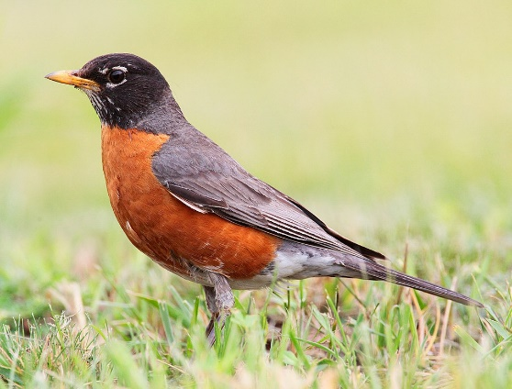**The Brave Robin**

In the meadow, bright and wide,

Lives a robin full of pride.

Red-breasted with feathers sleek,

Perched upon the fence to peek.

Singing songs both loud and clear,

Bringing joy to all who hear.

Building nests with care and skill,

High up on the sunny hill.

Hopping down to find a treat,

Worms and bugs it loves to eat.

Watching closely, quick and spry,

Catching insects as they fly.

As the sun begins to set,

Robin's heart is free of fret.

To its nest, it flies so high,

Underneath the starry sky.

1. What two adjectives has the poet used to describe the Brave robin? [2]

……………………………………………………………………………………………………………………….

1. What does the poet mean by the word ‘perched’? [1]

* soaring
* Sitting
* Flying

1. What does the robin love to eat? [1]

……………………………………………………………………………………………………………………….

1. Fill in the blanks with adjectives to complete the expanded noun phrase for the robin. [4]
2. The………………………… ………..……………….hill
3. It’s ………………………… ……………….………..songs

**Receiving gifts**

One sunny afternoon, Emma received some wonderful gifts from her family. First, her aunt gave her a beautiful red kite. It was big and bright, with a long tail that fluttered in the wind. Her aunt said, "This kite will fly high in the sky and bring you lots of joy." Emma thanked her and imagined all the fun she would have flying it in the park.

Later that day, Emma's uncle came over with a gift too. He handed her a box wrapped in colorful paper. Inside, Emma found a set of paints and brushes. "I know how much you love to paint," he said with a smile. "These are for you to create your masterpieces." Emma was thrilled and couldn't wait to start painting.

The next morning, Emma's cousin visited and surprised her with a small plant in a cute pot. "This is a sunflower seedling," her cousin explained. "With a little care, it will grow tall and bloom beautifully." Emma placed it on her windowsill, excited to watch it grow.

Each gift was special and thoughtful, reflecting the love and care of her family. Emma felt grateful and happy to have such wonderful people in her life.

1. Underline the adjective in the sentence below. [2]

Emma received some wonderful gifts from her family.

1. Why was Emma thrilled? [1]

…………………………………………………………………………………………………………………

1. Why did Emma place the sunflower seedling on her windowsill? [1]

…………………………………………………………………………………………………………………...

1. Fill in the blanks with the **past progressive form** of the verbs. [2]
2. a. Emma is imagining all the fun she will have flying the kite.

Emma ………………………………… all the fun she would have flying the kite.

1. Emma is creating a painting with her new paints.

Emma ………………………………… a painting with her new paints.

1. Underline the conjunctions in the sentences below. [3]
2. Emma received a red kite and a set of paints.
3. Her aunt gave her the kite but her uncle gave her the paints.
4. Emma was excited because she loved all the gifts.
5. Rewrite the sentence below. Make sure to use proper capitalization and punctuation. [4]
6. emma’s cousin gave her a sunflower seedling

……………………………………………………………………………………………………..

1. did you like the gifts emma received

…………………………….………………………………………………………………………..

1. Circle the **preposition** in the sentences below and match it to the suitable image. [4]

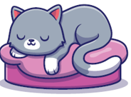

The cat is under the box



The cat is on the pillow

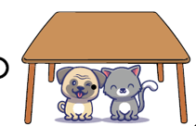

The dog is in the box



The dog and the cat are under the table

**Writing**

Write a recount about a camping trip. You can use the recount diagram to help you plan your recount. [15]

**My Recount planner**

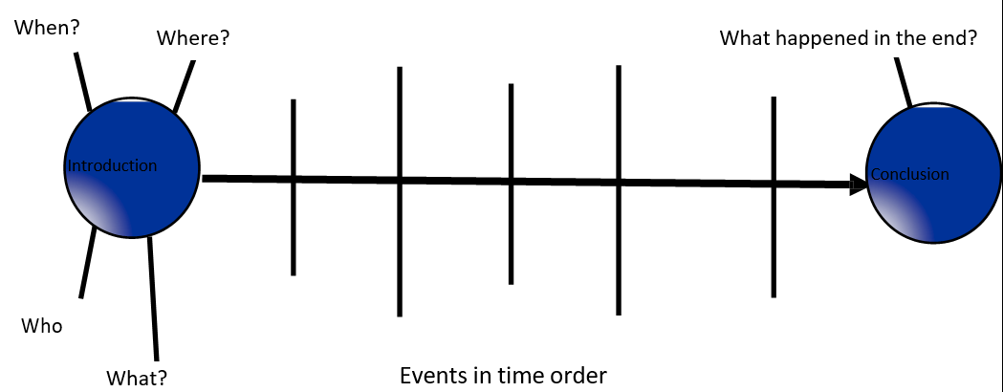

…………………………………………………………………………………………………………………………………………………………………………………………………………………………………………………………………………………………………………………………………………………………………………………………………………………………………………………………………………………………………………………………………………………………………………………….……………………………………………………………………………………………………………………………………………………………………………………………………………………………………………………………………………………………………………………………………………………………………………………………………………………………………………………………………………………………………………………….……………………………………………………………………………………………………………………………………………………………………………………………………………………………………………………………………………………………………………………………………………………………………………………………………………………………………………………………………………………………………………………….……………………………………………………………………………………………………………………………………………………………………………………………………………………………………………………………………………………………………………………………………………………………………………………………………………………………………………………………………………………………………………………….……………………………………………………………………………………………………………………………………………………………………………………………………………………………………………………………………………………………………………………………………………………………………………………………………………………………………………………………………………………………………………………….……………………………………………………………………………………………………………………………………………………………………………………………………………………………………………………………………………………………………………………………………………………………………………………………………………………………………………………………………………………………………………………….……………………………………………………………………………………………………………………………………………………………………………………………………………………………………………………………………………………………………………………………………………………………………………………………………………………………………………………………………………………………………………………….……………………………………………………………………………………………………………………………………………………………………………………………………………………………………………………………………………………………………………………………………………………………………………………………………………………………………………………………………………………………………………………….…………………………………………………………………………………………………………………………………………………………………………………………………………………………………………………………………………………………………………………………………………………………………………………………………………………………………………………………………………………………………………………………………………………………………………………………………………………………………………………………………………………………………………………………………………………………………………………………………………………………………………………………………………………………………………………………………

## ***Criteria***

|  |  |
| --- | --- |
| ***I have written my recount using past tense/ past progressive verbs.*** | *3* |
| ***I have time connectives in my recount.*** | *3* |
| ***My recount has an interesting Beginning middle and an end.*** | *3* |
| ***I have used appropriate capital letters and punctuation.*** | *3* |
| ***My writing is organised and follows a sequence.*** | *3* |