**Writing**

Write a recount about Visiting a Farm. You can use the recount diagram to help you plan your recount.

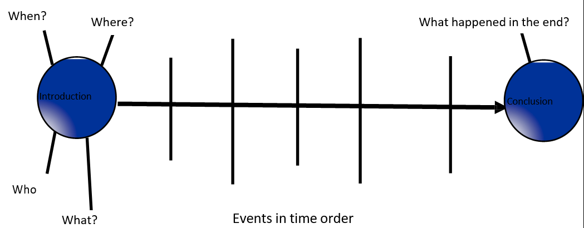**My Recount Planner**

…………………………………………………………………………………………………………………………………………………………………………………………………………………………………………………………………………………………………………………………………………………………………………………………………………………………………………………………………………………………………………………………………………………………………………………….……………………………………………………………………………………………………………………………………………………………………………………………………………………………………………………………………………………………………………………………………………………………………………………………………………………………………………………………………………………………………………………….……………………………………………

………………………………………………………………………………………………………………………………………………………………………………………………………………………………………………………………………………………………………………………………………………………………………………………………………………………………………………………………………….……………………………………………………………………………………………………………………………………………………………………………………………………………………………………………………………………………………………………………………………………………………………………………………………………………………………………………………………………………………………………………………….……………………………………………………………………………………………………………………………………………………………………………………………………………………………………………………………………………………………………………………………………………………………………………………………………………………………………………………………………………………………………………………….……………………………………………………………………………………………………………………………………………………………………………………………………………………………………………………………………………………………………………………………………………………………………………………………………………………………………………………………………………………………………………………….……………………………………………………………………………………………………………………………………………………………………………………………………………………………………………………………………………………………………………………………………………………………………………………………………………………………………………………………………………………………………………………….………………………………………………………………………………………………………………………………………………………………

## *Critera*

|  |  |
| --- | --- |
| ***I have written my recount using past tense/ past progressive verbs.*** | *3* |
| ***I have time connectives in my recount.*** | *3* |
| ***My recount has an interesting Beginning middle and an end.*** | *3* |
| ***I have used appropriate capital letters and punctuation.*** | *3* |
| ***My writing is organised and follows a sequence.*** | *3* |