1. **Open** [**Microsoft Make Code for micro:bit (microbit.org)**](https://makecode.microbit.org/#editor)
2. Make the given program.
3. Save your **project**.

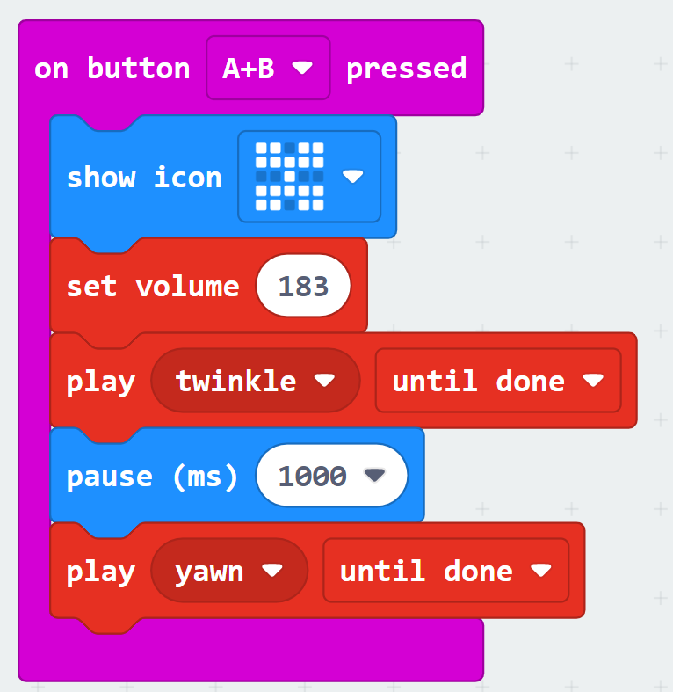

1. **Open Scratch Program.**

**Main Task:**

1. Put the steps in the algorithm below in the correct order. The algorithm is for a conversation between two characters. The **Prince** should speak first, then change costume. The **Horse** should then reply.

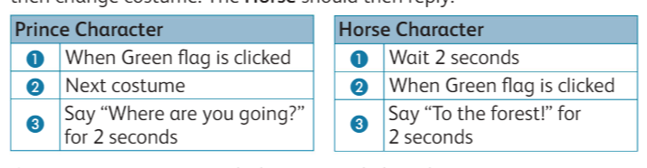

1. Create a program to match the corrected algorithms above.
2. Add two Backdrops to your project: **Castle 1** and **Woods.**
3. Click on the Backdrop thumbnail and add code so that:

When the **Green flag** is clicked, the backdrop switches to the **Castle 1** Backdrop.

After five seconds, the backdrop switches to the **Woods** Backdrop.

1. Add the **Tree 1** sprite as a static object.
2. Change the code created in part 2 so the **Horse** speaks for twice as long.

1. Add the following code to the **Horse** sprite. Run your final program and save it.

**Extension Task:**

Once you have finished, you can extend the story. You could:

1. add extra lines of conversation.
2. get the Horse and Prince to move.
3. change the backdrops and continue the story.