**1) Read the algorithm and match it with right components.**

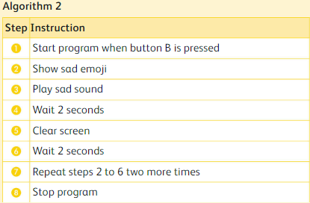

|  |  |
| --- | --- |
| Component | Algorithm 1 |
| 1.What is used to start the program? | a. 3 times |
| 2.Which emoji is displayed on the screen? | b. Sad sound |
| 3.Which sound is displayed at the same time? | c. Button B |
| 4.How long the emoji is displayed for? | d. Sad emoji |
| 5.How many times does the program repeat? | e. 2 seconds |

|  |  |  |  |  |
| --- | --- | --- | --- | --- |
| 1. | 2. | 3. | 4. | 5. |
|  |  |  |  |  |

2) Read the algorithm and fill in the blanks.

**Display the confused emoji for 5 seconds and play the twinkle sound when the micro:bit is shaken. This is repeated for 5 times.**

