**1) Read**- Display a surprised emoji for 1 second and play the spring sound when buttons A and B are pressed at the same time. This is repeated two times.

**Cut and paste from the below word and complete the blanks of the algorithm.**

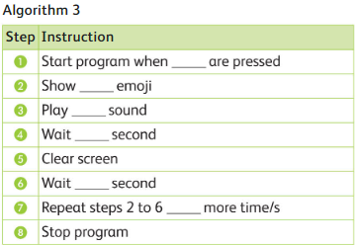

|  |  |
| --- | --- |
| Step | Instructions |
| 1 | Start program when ______________are pressed |
| 2 | Show ___________ emoji |
| 3 | Play ______________ sound |
| 4 | Wait ____________ second |
| 5 | Clear screen |
| 6 | Wait ______ second |
| 7 | Repeat steps 2 to 6 ___________ more time/s |
| 8 | Stop program |

1

one

Spring

Surprised

1

A & B