1. Draw the number of 2p coins to make these amounts. /2



14p

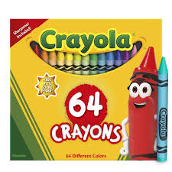

18p

1. Write correct mathematical symbol to make the number sentences correct. /4

+ - =

a) 20 ______ 40 = 60

b) 82 ______ 62 = 20

c) 20 + 2 _______ 18 + 4

d) 25 ______ 6 = 19

1. Complete the sentences. /4

a) Half of 6 is _______

b) Double of 7 is ______

c) Half of 18 is _______

d) Double of 8 is ________

1. 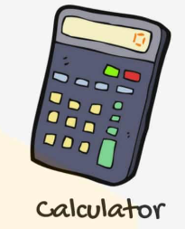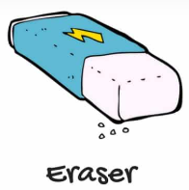At the stationary store, Hussain, Arzaan and Haris went to shop. Look at the amount of the things they bought and write their total in the form of complete number sentences. /3



21 p 31 p 20 p 12p 30p

a) Hussain bought stapler and glue.

Total: _____________________________

b) Arzaan bought pencil sharpener and calculator.

Total: ______________________________

c) Haris bought eraser and glue.

Total: _______________________________

1. Write two numbers to make this calculation correct. /2

+ + = 18

Now, write three numbers to make this calculation correct.

+ + = 18

1. Write the multiplication number sentences for these repeated addition number sentence. /3

a) 2 + 2 + 2 + 2 = 8

_______________________________

b) 3 + 3 + 3 + 3 + 3 = 15

_______________________________

c) 4 + 4 + 4 = 12

______________________________

1. Write the digital times shown in the clocks. /2

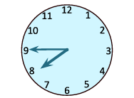a) 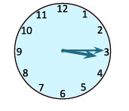 b)

_____________________________ ___________________________

1. Draw the hands-on clock to show the time. /4

a) Nine 0 clock b) Quarter past 10

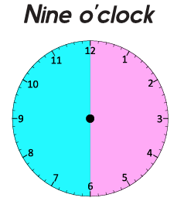

c) Quarter to 8 d) Half past 3



1. It is 7 o’clock in the first clock. What time it will be half an hour later? Draw hands on the clock to show your answer AND write the digital time.

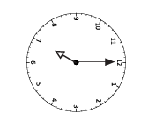 /2

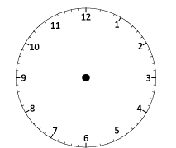

________________

Half an hour later Digital time

1. Write **T** for true and **F** for false in the space provided. /4

a) Half of 6 is 12. ________

b) Double of 8 is 16. ________

c) Double 9 is 19. __________

d) Half 20 is 10. _________

1. Use the grid to help solve these calculations. /4

a) 62 + 23 = _________

b) 89 – 32 = _________

c) 23 + 34 = _________

d) 38 – 12 = __________

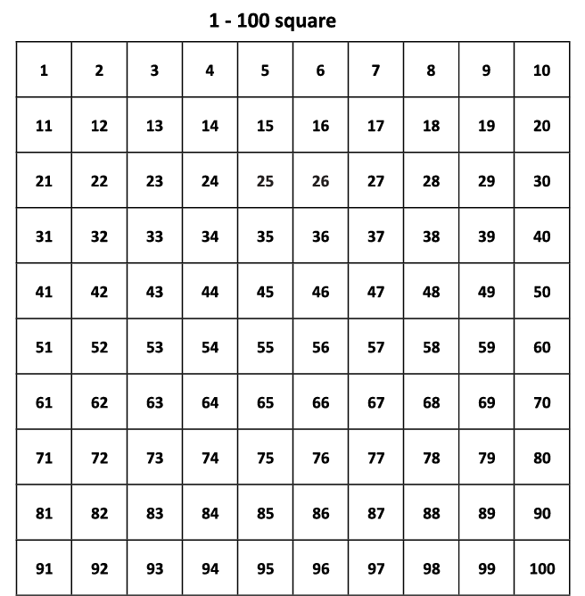

1.  Complete these sentences. /3

Half of 16 is ________,

So, Double _________ is ________.



Half of 12 is ________,

So, Double _________ is ________.



Half of 20 is ________,

So, Double _________ is ________.

1. How many strawberries are in the 2 plates? Write your answers in the form of addition AND multiplication number sentence. /2





Addition number sentence: _______________________________

Multiplication number sentence:_______________________________

14. Write two things that take about **a second.** /1

**___________________________________**

___________________________________

Teacher’s Signature:______________________ Parent’s Signature:________________