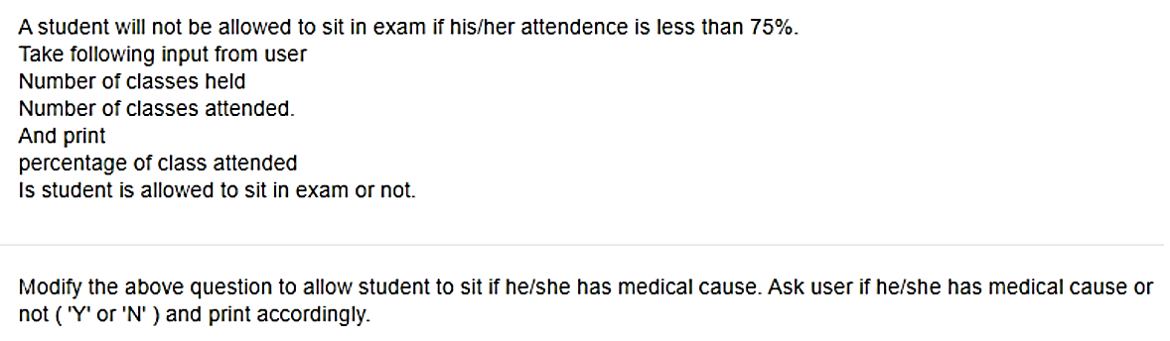Task-1

Task-2

Make a **Flowchart** and Write **Python program** for given problem and make it run.

In case of errors find and remove the errors.

Use comments were needed.