Quiz 5 - MS
ELECTRONIC CONFERENCING
Question | Answer | Marks
1. | 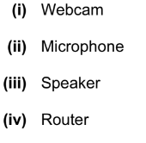 | 1  1  1  1
2 | Four from:  Real time collaboration/communication  Multiple users are connected to the internet.  See the same screen at all times in their web browsers  Allows: texting, for example of the car details  VOIP, for example, the delegates discussing the car range  Full motion video to show the car being test driven | 4
3 | Any two from  Web cams  Large monitors / television screens  Microphones  speakers | 2

