**QUIZ-5 (GRADED)**

**ELECTRONIC CONFERENCING**

1. A video-conference is being set up.

Complete each sentence below using the most appropriate device from the list. [4]

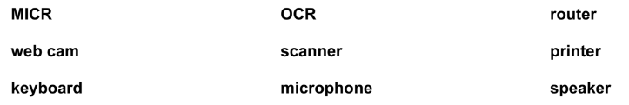

1. Moving images are input using a ……………………………………………………………………………………………
2. Sound is input using a ……………………………………………………………………………………………………………
3. Sound is output using a ………………………………………………………………………………………………………….
4. Connection to the Internet is made using a ……………………………………………………………………………
5. The directors of a multi-national car company need to communicate with each other. They have

decided that the best way to do this is through web-conferencing.

1. Describe web-conferencing and how it could be used in this scenario. [4]

……………………………………………………………………………………………………………………………………………………………………………………………………………………………………………………………………………………………………………………………………………………………………………………………………………………………………………………………………………………………………………………………………………………………………………………………………………………………………………………………………………………………………………………………………………………………………………………………………………………………………………………………………………………………………………………………….

1. A company is setting up a video conference.

Name two computer hardware devices they would need. [2]

1…………………………………………………………………………………………………………………………………………………………2…………………………………………………………………………………………………………………………………………………………