Strange but True! – Activity 1

Read these five extracts from Strange but True! Choose the correct heading to write above each. Underline the modal verb in each of these headings.
- Which other modal verbs would have the same meaning? Write a new heading with a different model verb and roughly the same meaning.
- Which other modal verbs would make sense, but change the meaning? Write a new heading with a different modal verb and a new meaning.

Headings
Giant pictures would have remained hidden without airplanes.
You might think they were real trees.
Chimneys will not last forever
Coffins can come in all shapes and sizes.
Secret pools can still frighten.
1. Underwater archaeologists exploring Mexico’s cenotes (secret pools) have found human skulls and bones suggesting that the Mayan people carried out human sacrifices to honour their gods. The discoveries have scared villagers living near the cenotes today, who steer clear of these pools. | 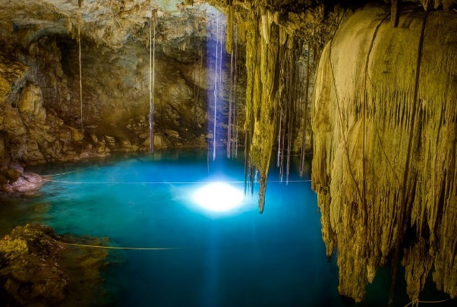

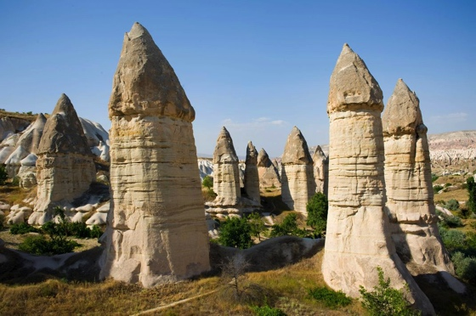 | 2. Fairy chimneys in Turkey are formed with a hard basalt cap. If a fairy chimney loses its basalt cap, it will eventually disappear completely.

Headings
Giant pictures would have remained hidden without airplanes.
You might think they were real trees.
Coffins can come in all shapes and sizes.
Chimneys will not last forever
Secret pools can still frighten.

3.Funerals in the West African country of Ghana are upbeat gatherings. Innovative coffins celebrate the deceased’s work or interests. Coffins can be made in the shape of aircraft, cameras and animals. | 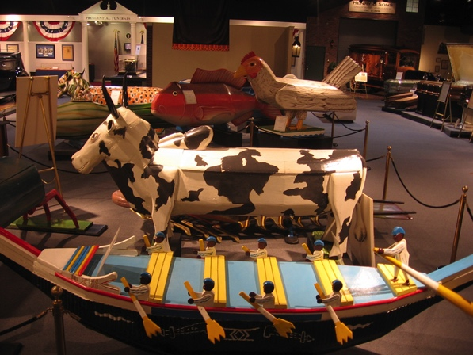

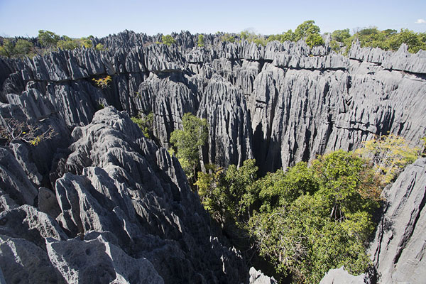 | 4. Like an enchanted forest that’s been turned to stone, Grand Tsingy in Madagascar is a sombre scene of spiky, tree-like rocks. The world’s largest stone forest was carved by tropical rain in a process that lasted millions of years.

5. Aircraft pilots flying over Peru’s Nazca desert in the 1930s were amazed to see huge drawings scratched into the landscape. | 