- A student carries out an electrolysis experiment using the apparatus shown.
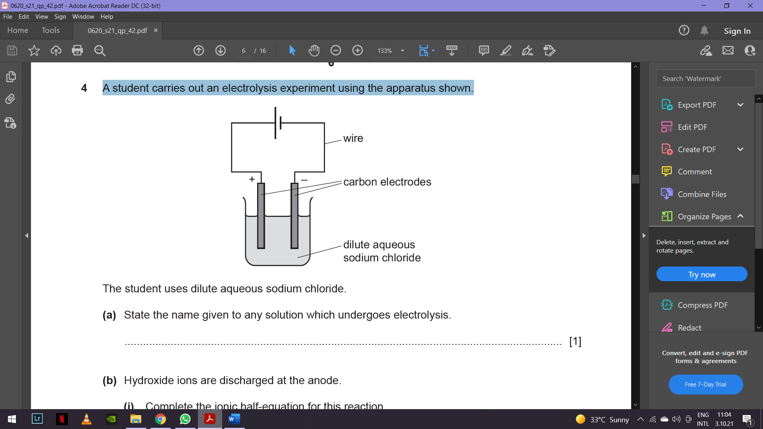
The student uses dilute aqueous sodium chloride.
(a) State the name given to any solution which undergoes electrolysis.
…………………...................................................................................................................................[1]
(b) Hydroxide ions are discharged at the anode.
(i) Complete the ionic half-equation for this reaction.
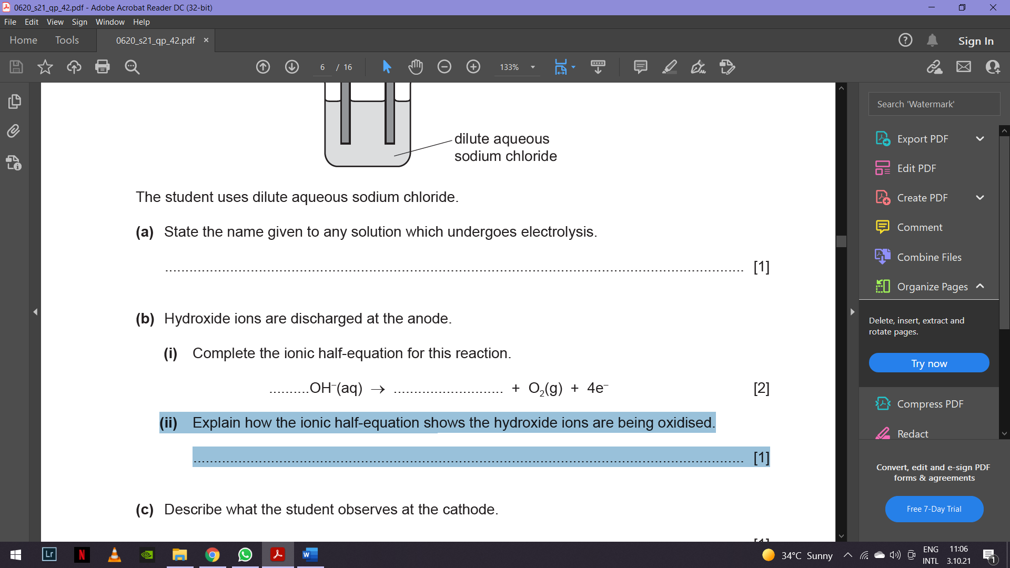
(ii) Explain how the ionic half-equation shows the hydroxide ions are being oxidised.
.................................................................................................................................................... [1]
(c) Describe what the student observes at the cathode.
………………….................................................................................................................................. [1]
(d) Write the ionic half-equation for the reaction at the cathode.
…………………...................................................................................................................................[1]
(e) The student repeats the experiment using concentrated aqueous sodium chloride.
(i) Describe what the student observes at:
● the cathode ...................................................................................................................
● the anode. ................................................................................................................. [2]

(ii) The student added litmus to the solution after the electrolysis of concentrated aqueous
sodium chloride.
State the colour seen in the solution. Give a reason for your answer.
colour of solution .................................................................................................................
reason................................................................................................................................ [1]
(f) Carbon electrodes are used because they are inert.
State another element that can be used instead of carbon.
……………………...............................................................................................................................[1]

- In the industrial electrolysis of concentrated sodium chloride solution, it is necessary to keep the chlorine gas and sodium hydroxide separated. Why? …………………………………………………………………………………………………………………………………………………………………………………………………………………….. ……………..[2]
- In the electrolysis of concentrated aqueous sodium bromide hydrogen is one of the product.
- Write an equation for the electrode reaction which forms hydrogen.
…………………………………………………………………………………………………… [2]
(b) Name the other two products of the electrolysis of concentrated aqueous sodium
bromide
(i)……………………………………………………………………………………………………[2]
(ii)……………………………………………………………………………………...………… [2]
(b) In the electrolysis of ionic salt, explain why the substance has to be molten or aqueous for electrolysis to happen.
……………………………………………………………………………………………………………………………………………………………………………………………………………… [2]

