**WORKSHEET**

**Serial & Parallel**

Connect the devices that support serial / parallel transmission with labels.

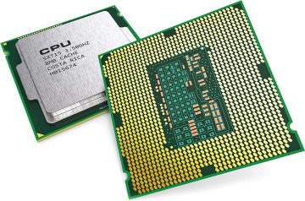

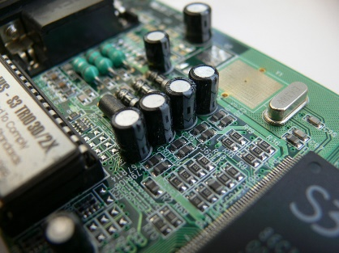

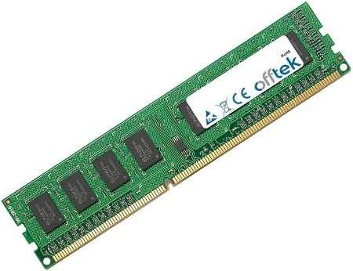

Key Points

__________________________________________________________________________________

__________________________________________________________________________________

__________________________________________________________________________________

__________________________________________________________________________________

__________________________________________________________________________________

__________________________________________________________________________________

__________________________________________________________________________________

__________________________________________________________________________________

__________________________________________________________________________________

__________________________________________________________________________________

__________________________________________________________________________________

__________________________________________________________________________________

__________________________________________________________________________________

__________________________________________________________________________________

__________________________________________________________________________________

__________________________________________________________________________________

__________________________________________________________________________________

__________________________________________________________________________________

__________________________________________________________________________________

__________________________________________________________________________________

__________________________________________________________________________________

__________________________________________________________________________________