**Unit 4 – Staying Alive**

**4.2 Animal groups and different life cycles**

**Think like a scientist: Height increases from baby to child**

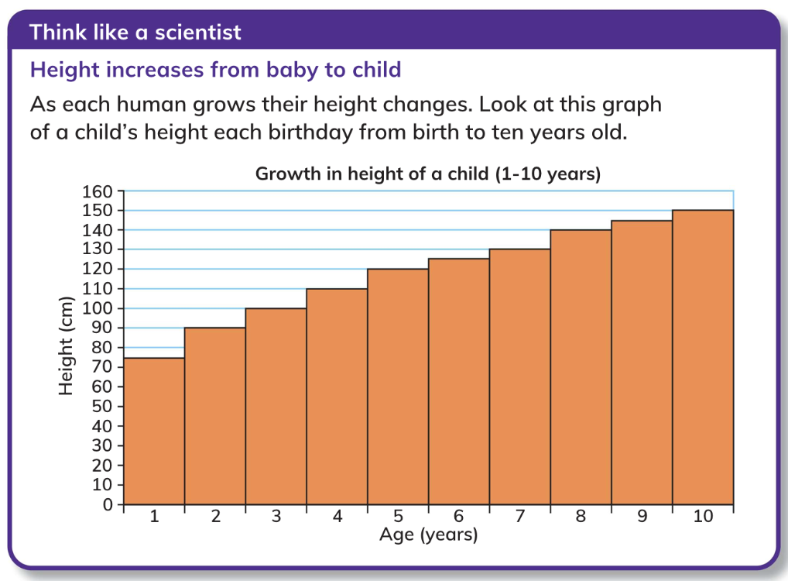

1. ﻿﻿What was the child's height at 2 years old? /2

________________________________________________________________________________________________________________________________________________________________________________________________________________________

1. ﻿﻿From age 1 to 2 years how much did the child's height increase? /2

________________________________________________________________________________________________________________________________________________________________________________________________________________________

1. From age 9 to 10 years how much did the child's height increase? /2

________________________________________________________________________________________________________________________________________________________________________________________________________________________

1. Why might a doctor or parent might be pleased to see this graph? /2

________________________________________________________________________________________________________________________________________________________________________________________________________________________

1. Predict what could be the height of the child at 12 years. /2

________________________________________________________________________________________________________________________________________________________________________________________________________________________

**Self-reflection criteria:**

* I can use a diagram to show how life cycles work.
* I can use a bar chart to answer questions.
* I can use information sources to research and answer questions.