Revision worksheet 3

1. Use 100-grid or bead bar to help you solve the following problems.
2. 47 + 10 = ________
3. 87 - 10 = _________
4. 42 + 11 = _________
5. 65 – 11 = _________
6. 88 – 23 = _________
7. 72 – 21 = _________
8. 68 + 21 = __________
9. 54 + 31 = __________
10. 65 + 30 = __________
11. 87 – 40 = __________
12. 73 – 50 = __________

2. Write the missing numbers in these additions.

1. ______ + 11 = 61
2. ______ + 31 = 99
3. ______ + 40 = 88

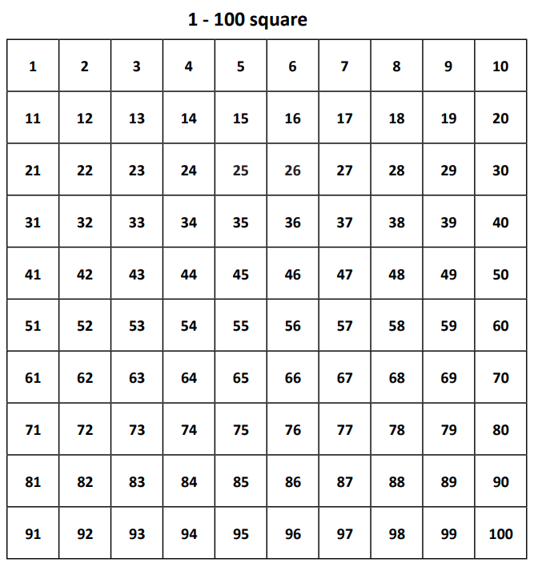

Teacher’s Signature:______________________ Parent’s Signature:________________