Question | Description | Marks
1 | One mark per each correct binary value.  One mark per each correct hex value.  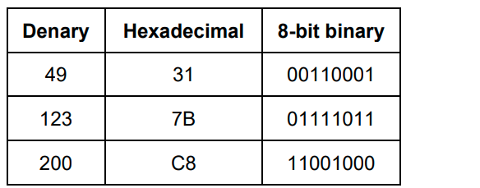 | 6
2 | Any four from:  − MAR  − MDR  − PC  − ALU  − CU  − ACC  − CIR  − Buses  − Registers | 4
3 | Input  − Black  − White  − Sensors  − Binary  One mark for each correct term in the correct place | 5
4 | Any five from:  • Data fetched from RAM is stored in the MDR  • Data from MDR is sent to ALU to be executed  • ALU performs calculation and logical operations on data  • ALU has a built-in register ...  • ... where it stores interim results of calculations  • After calculations, ALU sends data to MDR  • Data is sent from MDR to be written to RAM | 5
5 | Common device for data entry.  Device used to capture the images.  A series of dark and light parallel lines of varying thickness.  matrix of filled-in dark squares on a light background. | 4
6 a | DECLARE Sum, Number : Integer  Sum <- 0  FOR Number <- 1 TO 10  Sum <- Sum + Number  NEXT Number  OUTPUT "The sum of the first 10 numbers is: ", Sum | 5
6 b | Start  Sum = 0  Num = 0  Is num <= 10  false  True  Sum = sum + num  Num = num + 1  End | 5
7 a | CASE expression  value1 : code block or statement block for value1  value2 : code block or statement block for value2  ...  valueN : code block or statement block for valueN  OTHERWISE : code block or statement block to execute if none of the above values match  END CASE | 2
7 b | IF condition THEN  // statements to execute if the condition is true  ELSE  // statements to execute if the condition is false  ENDIF | 2
7 c | WHILE condition DO  // Statements to be executed repeatedly while the condition is true  ENDWHILE | 2

