**Term I REVISION PAPER**

**DECEMBER 2023 - 24**

**Key Stage 3 (Year VIII __)**

**Date : Feb – March 2024**

**Name of the Candidate : __________________________________________**

**Subject : Computer Science**

**Total Maximum Marks : 40**

**INSTRUCTIONS**

**Answer all questions.**Use a black or dark blue pen.  
Write your name, center number and candidate number in the boxes at the top of the page. Write your answer to each question in the space provided.  
Do **not** use an erasable pen or correction fluid.  
Do **not** write on any bar codes.  
You may use an HB pencil for any diagrams, graphs, or rough work.

**The total mark for this paper is 40.**The number of marks for each question or part question is shown in brackets [ ].  
No marks will be awarded for using brand names of software packages or hardware.

|  |  |  |
| --- | --- | --- |
| **Section** | **Maximum Marks** | **Marks Obtained** |
| **A** | **40** |  |
| **Total** | **40** |  |

**Checked by : ____________________________**

**Re-checked by : ____________________________**

1. A denary value can be converted into hexadecimal and binary.

(a) Complete the table to show the hexadecimal and 8-bit binary values of the given denary

values.

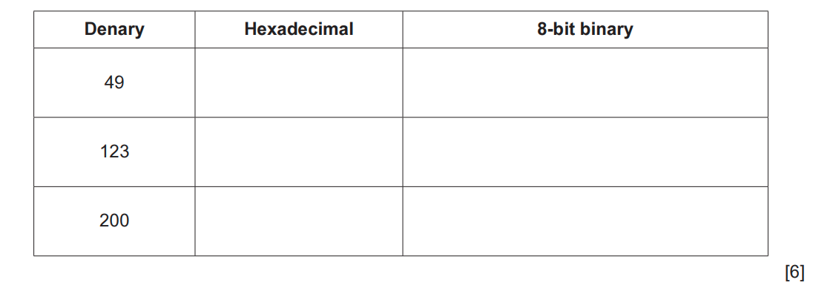

Working Space

..........................................................................................................................................................................................................................................................................................................................................................................................................................................................................................................................................................................................................................................................................................................................................................................................................................................................................................................

1. Identify four components that are part of the CPU.

Component 1 .....................................................................................................................

Component 2 .....................................................................................................................

Component 3 .....................................................................................................................

Component 4 .....................................................................................................................

[4]

1. Genevieve writes a paragraph about a barcode reader.

Using the list given, complete the paragraph. Not all terms in the list need to be used.

• actuators

• binary

• black

• input

• microprocessors

• output

• sensors

• storage

• white

A barcode reader is an ............................................... device. It shines a light at the barcode

and the light is reflected back. The ............................................... bars in the barcode reflect

less light than the ............................................... bars.

............................................... are used to capture the amount of reflected light and the

different reflections are converted to ............................................... values.

**[5]**

4. A student uses a laptop and a calculator for schoolwork.

(a) The laptop has a central processing unit (CPU) that performs the fetch–decode–execute

cycle.

The CPU has several components, including the memory data register (MDR) and the

arithmetic logic unit (ALU).

 Describe how the MDR and the ALU are used in the fetch–decode–execute cycle.

...................................................................................................................................................

...................................................................................................................................................

...................................................................................................................................................

...................................................................................................................................................

...................................................................................................................................................

...................................................................................................................................................

...................................................................................................................................................

...................................................................................................................................................

...................................................................................................................................................

.............................................................................................................................................. [5]

1. Four input devices are shown on left side in the diagram below. Four applications are shown on the right side of the diagram.

By drawing arrows, link each application to the appropriate input device.

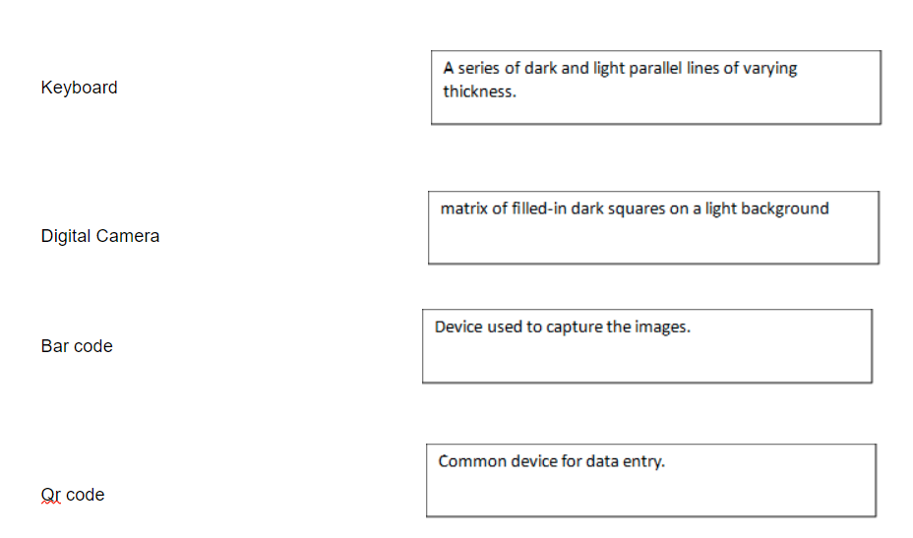

[4]

6. A program is required to add first ten natural numbers:

a) Write a pseudocode to find the sum of first ten natural numbers (1 – 10) using FOR TO NEXT loop.

Pseudocode

………………………………………………………………………………………………………………………………………………

………………………………………………………………………………………………………………………………………………

………………………………………………………………………………………………………………………………………………

………………………………………………………………………………………………………………………………………………

………………………………………………………………………………………………………………………………………………

………………………………………………………………………………………………………………………………………………

………………………………………………………………………………………………………………………………………………

………………………………………………………………………………………………………………………………………………

………………………………………………………………………………………………………………………………………………

………………………………………………………………………………………………………………………………………………

………………………………………………………………………………………………………………………………………………

………………………………………………………………………………………………………………………………………………

……………………………………………………………………………………………………………………………………………

………………………………………………………………………………………………………………………… [5]

b) Draw a flowchart for the program in part (a)

Flowchart:

[5]

7. Write the syntax / basic structure of the following:

a. CASE OF OTHERWISE:

………………………………………………………………………………………………………………………………………………

………………………………………………………………………………………………………………………………………………

………………………………………………………………………………………………………………………………………………

………………………………………………………………………………………………………………………………………………

………………………………………………………………………………………………………………………………………………

…………………………………………………………………………………………………………………………… [2]

b. IF THEN Statement

………………………………………………………………………………………………………………………………………………

………………………………………………………………………………………………………………………………………………

………………………………………………………………………………………………………………………………………………

………………………………………………………………………………………………………………………………………………

………………………………………………………………………………………………………………………………………………

……………………………………………………………………………………………………………………………… [2]

c. WHILE DO ENDWHILE

………………………………………………………………………………………………………………………………………………

………………………………………………………………………………………………………………………………………………

………………………………………………………………………………………………………………………………………………

………………………………………………………………………………………………………………………………………………

……………………………………………………………………………………………………………………………………………

…………………………………………………………………………………………………………………………………… [2]