**Marketing mix: Promotion**

**Starter activity:**

Q. Which method of promotion is being used in the folowig pictures?

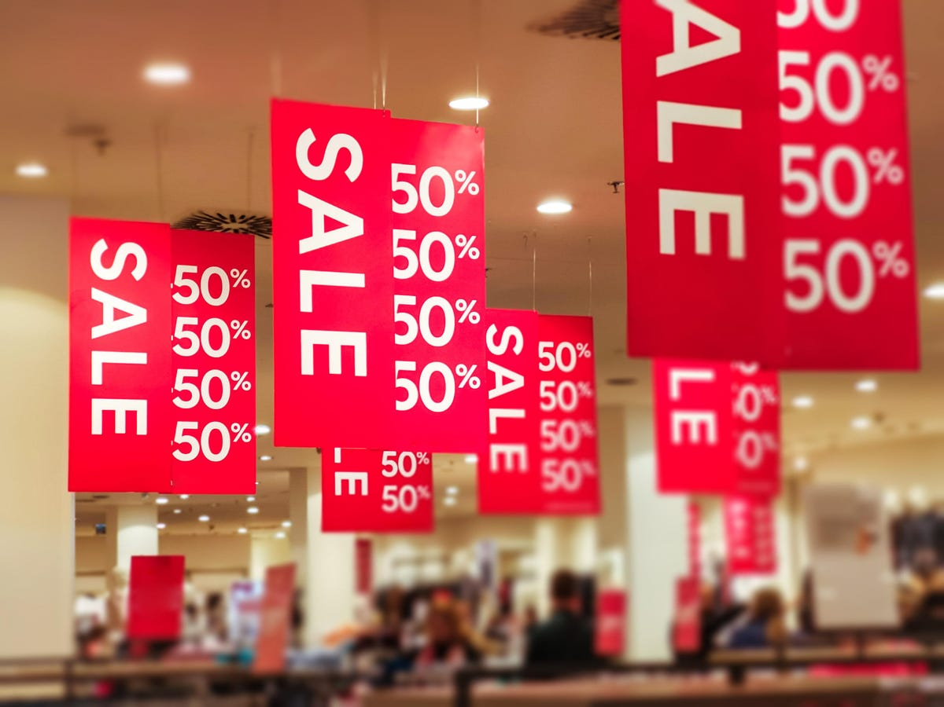

_______________________

_____________________________

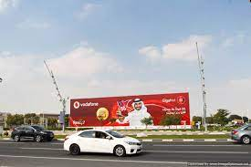

________________________________

**What is meant by promotion?**

**……………………………………………………………………………………………………………………………………………………………….**

**……………………………………………………………………………………………………………………………………………………………….**

**Development activity:**

**Read book page 182-185 and then write a definition and one example for each the following methods of promotion:**

|  |  |
| --- | --- |
| **Key term** | **Definition and example** |
| **Advertising** |  |
| **Informative advertising** |  |
| **Persuasive advertising** |  |
| **Below-the-line promotion** |  |
| **Sales promotion** |  |
| **Personal selling** |  |
| **Direct mail** |  |
| **Sponsorship** |  |

**Summary notes:**

**Qatar National Identity**

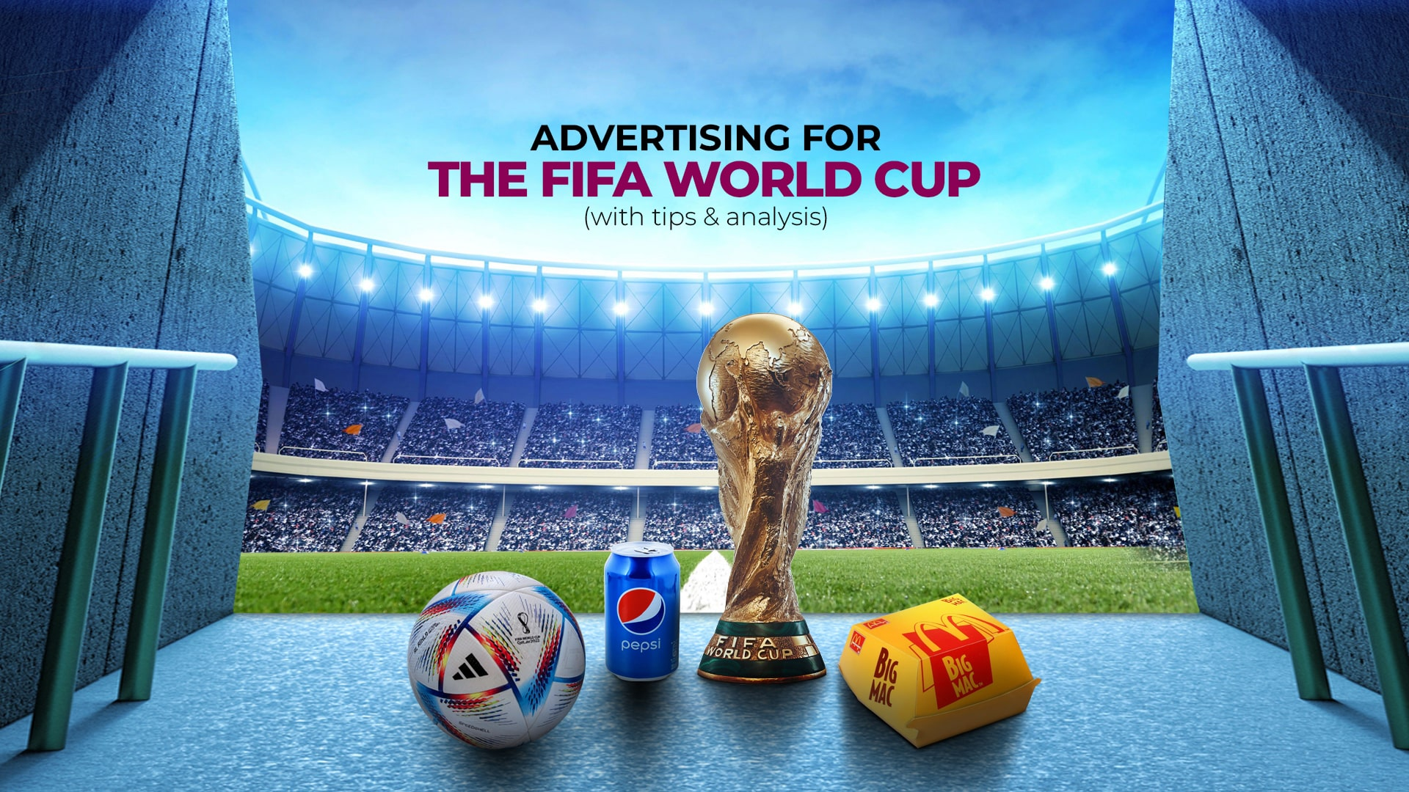

Q. List down all the different methods of promotion that were used to promote Qatar FIFA World cup 2022.

**……………………………………………………………………………………………………………………………………………………………….**

**……………………………………………………………………………………………………………………………………………………………….**

**……………………………………………………………………………………………………………………………………………………………….**

**……………………………………………………………………………………………………………………………………………………………….**

**……………………………………………………………………………………………………………………………………………………………….**

**……………………………………………………………………………………………………………………………………………………………….**

**……………………………………………………………………………………………………………………………………………………………….**

**……………………………………………………………………………………………………………………………………………………………….**

**……………………………………………………………………………………………………………………………………………………………….**

**……………………………………………………………………………………………………………………………………………………………….**

**……………………………………………………………………………………………………………………………………………………………….**

**……………………………………………………………………………………………………………………………………………………………….**

**……………………………………………………………………………………………………………………………………………………………….**

**Practice activity:**

