**QUIZ-2**

**E-Safety (Marking Scheme)**

1. [6] 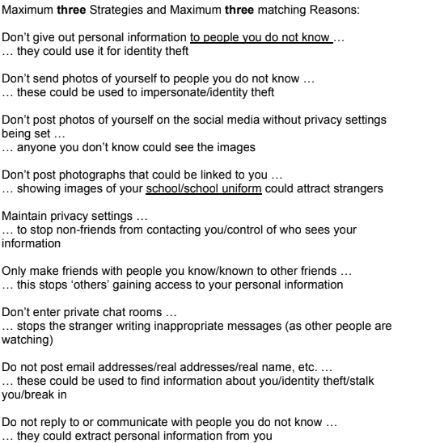

1. **E-safety, safe, meet, personal** [4]