**YEAR 3 - BASELINE TEST**

1. **Understanding: (8)**
2. Who revealed the Quran?

______________________________________________________________

1. Name the angel who brought the Quranic verses to Rasulullah SAW?

______________________________________________________________

1. To whom the Quran was revealed?

_____________________________________________________________

1. What is the language of the Quran?

______________________________________________________________

1. How many Surahs are there in the Quran?

______________________________________________________________

1. Which is the shortest Surah in the Quran?

______________________________________________________________

1. What was the first word of the Qur’an that was revealed to Prophet Muhammad (pbuh)?

_______________________________________________________________

1. Where the Prophet Muhammad (peace be upon him) received his first revelation from Allah swt?

______________________________________________________________

1. **Tajweed:**

**(3)**

1. How many throat letters are there in tajweed?

______________________________________________________________

1. Name throat letters?

______________________________________________________________

1. How many levels are there in throat letters?

______________________________________________________________

1. **Write the Throat letters )(هـ/ع/ح/خ/ء/غ) (Top-Middle-Bottom)on the Throat (6)**

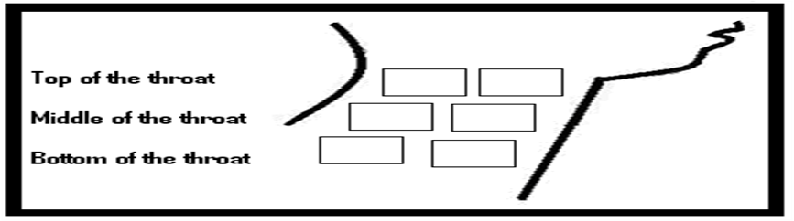

1. **Memorization:**

**(3)**

Recite Surah Al Nasr or Surah Ikhlas.