Worksheet 1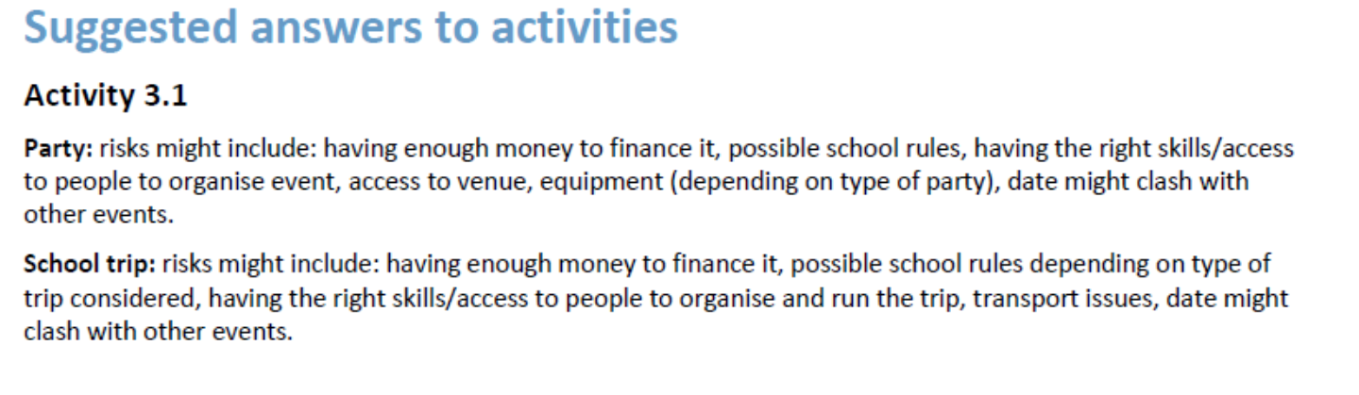
Worksheet 2
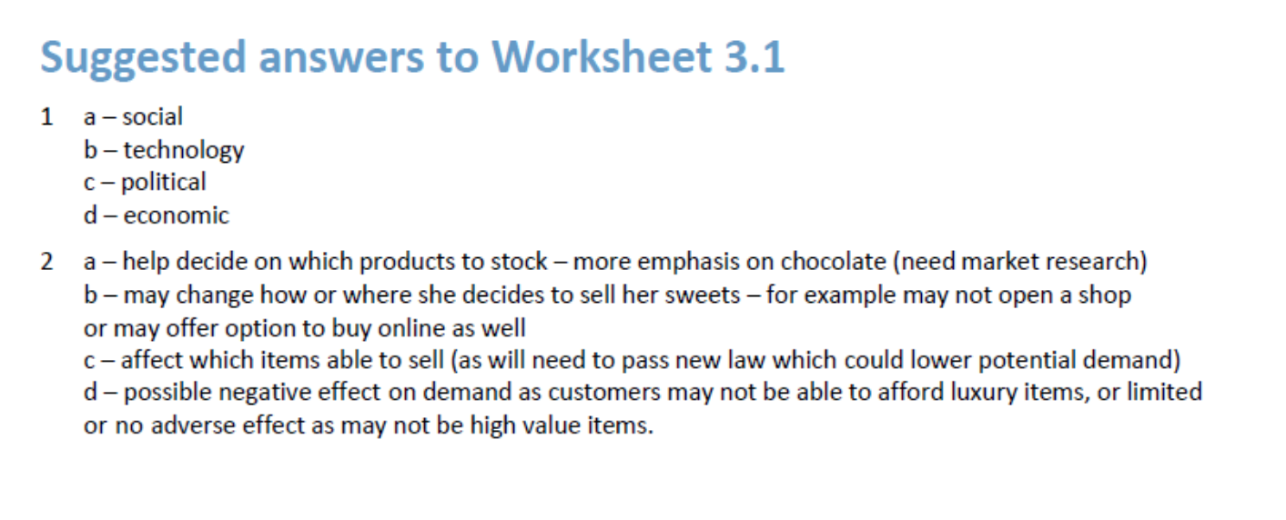

Formative assessment answers
Crossword answers (formal formative)
