**Opportunities, risk , legal and ethical considerations**

**Total Time: 25-30 min**

**Total marks: 15 marks**

**Q1. Complete the crossword given below: (5)**

Q1. Refer to the case study below. Give examples of risks this enterprise has faced. (6)

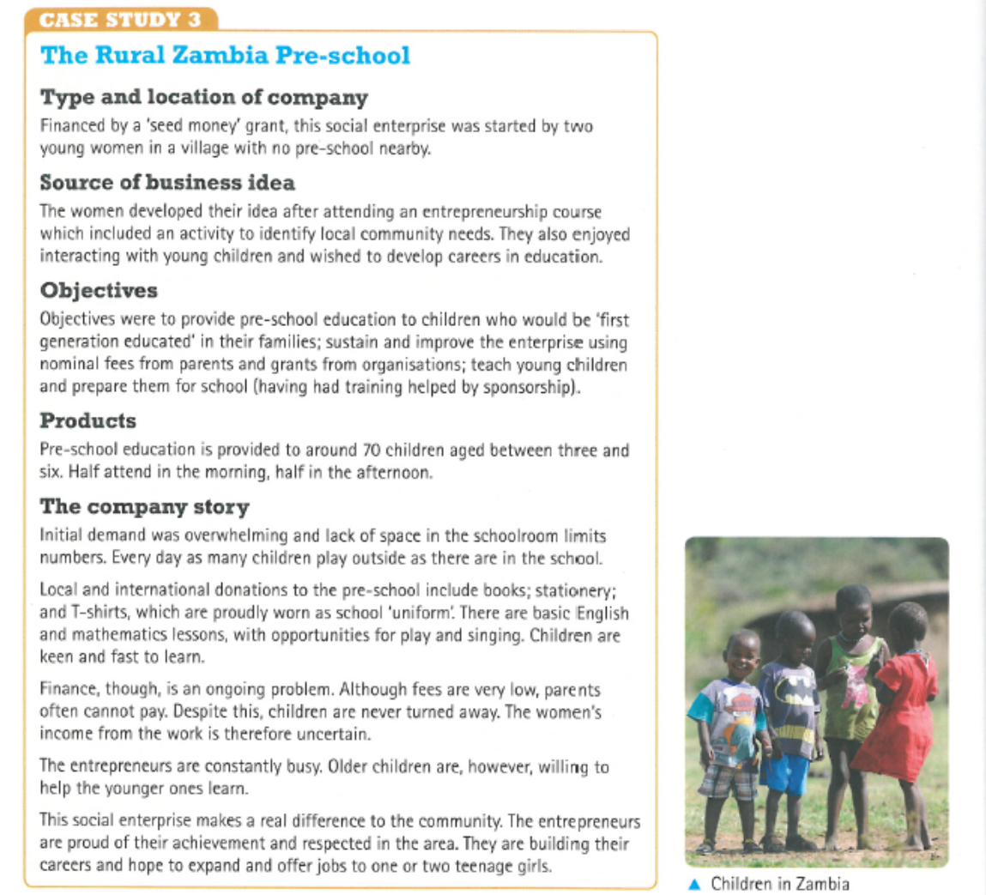

……………………………………………………………………………………………………………………………………………………………….

……………………………………………………………………………………………………………………………………………………………….

……………………………………………………………………………………………………………………………………………………………….

……………………………………………………………………………………………………………………………………………………………….

……………………………………………………………………………………………………………………………………………………………….

……………………………………………………………………………………………………………………………………………………………….…

…………………………………………………………………………………………………………………………………………………………….

……………………………………………………………………………………………………………………………………………………………….

……………………………………………………………………………………………………………………………………………………………….

……………………………………………………………………………………………………………………………………………………………….

……………………………………………………………………………………………………………………………………………………………….

……………………………………………………………………………………………………………………………………………………………….

……………………………………………………………………………………………………………………………………………………………….

……………………………………………………………………………………………………………………………………………………………….

……………………………………………………………………………………………………………………………………………………………….

Q2. Produce a SWOT analysis for the enterprise in the above case study. (4)

|  |  |
| --- | --- |
| **Strengths** | **Weaknesses** |
|  |  |
| **Opportunities** | **Threats** |
|  |  |