**These points will help you**

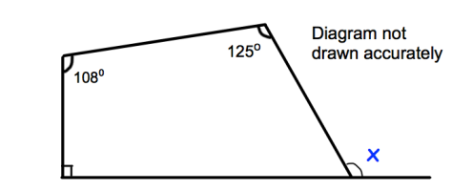

**Sum of angles of a quadrilateral is 360 $°$**

**Angles on a line add up to 180 $°$**

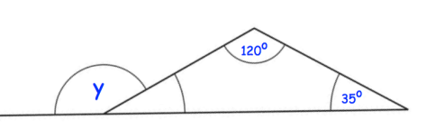

**Sum of angles in a triangle is 180 $°$**

**Angles on a line add up to 180 $°$**

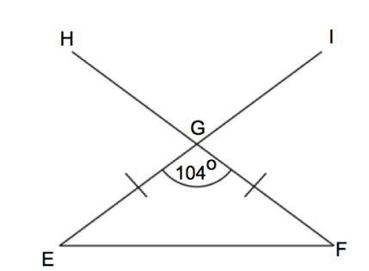

**x**

**Base angles of an isosceles triangle**

**Are equal**

**Vertically opposite angles are equal**

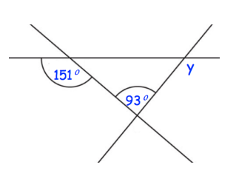

**Sum of angles in a triangle is 180 $°$**

**Angles on a line add up to 180 $°$**

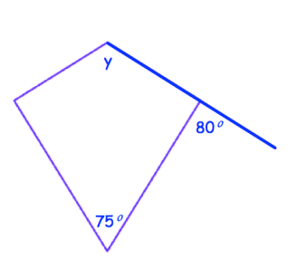

**Sum of angles of a quadrilateral is 360 $°$**

**Angles on a line add up to 180 $°$**

**Angles made by non-equal sides of a kite are equal**

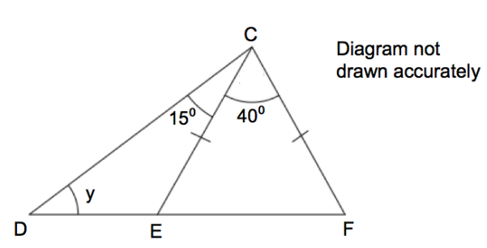

**Base angles of an isosceles triangle**

**Are equal**

**Angles on a line add up to 180 $°$**

**Angles of a triangle add up to 180 $°$**

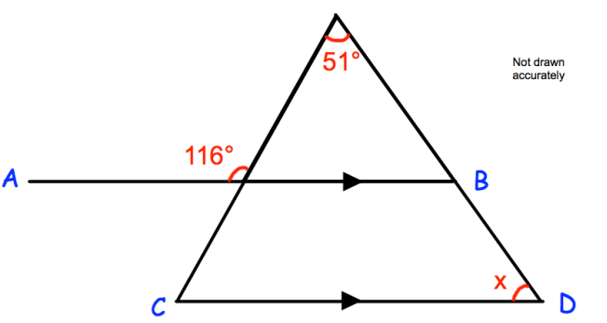

**Sum of angles in a triangle is 180 $°$**

**Angles on a line add up to 180 $°$**

**Corresponding angles are equal**

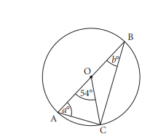

**Base angles of an isosceles triangle**

**Are equal**

**Angles on a line add up to 180 $°$**

**Angles of a triangle add up to 180 $°$**

**Angles on a line**

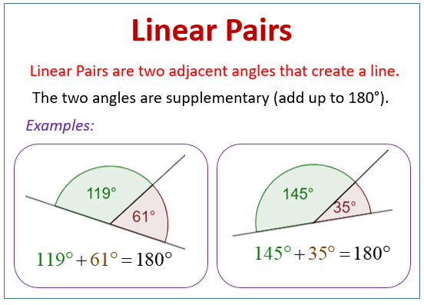

**Vertically opposite angles**

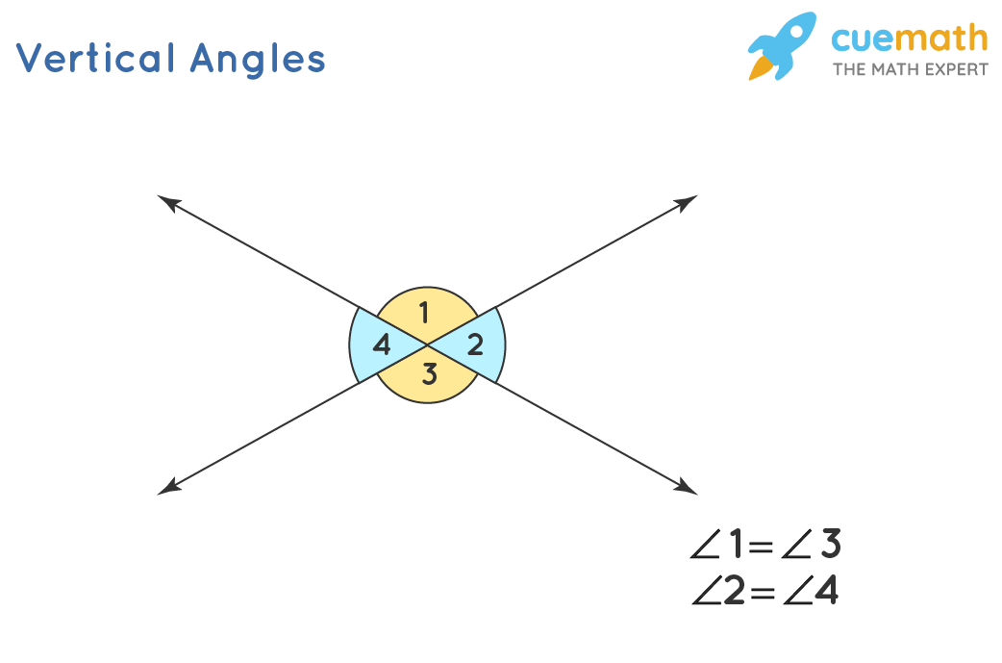

**Corresponding angles**

