Built in Functions (Library routines)– Programming Concepts
Activity 1:
- Using the Python IDE, obtain the output for each of the following print statements, and indicate briefly what the predefined function does:
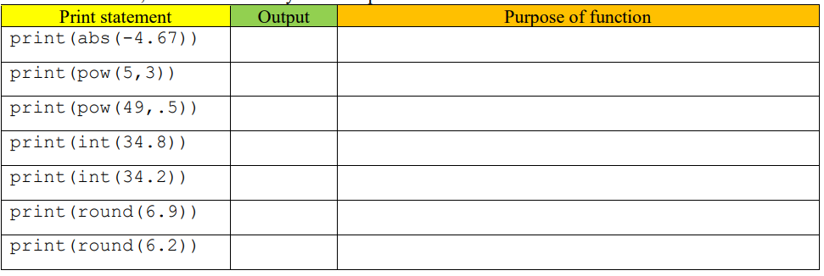
- Is there a difference between the round() function and the int() function? If so, what is the difference?
--------------------------------------------------------------------------------------------------------------------------
--------------------------------------------------------------------------------------------------------------------------
--------------------------------------------------------------------------------------------------------------------------
Activity 2:
Application Questions: Use the python interpreter to check your work.
- Write a line of code that prints the integer portion of the number 21.45
………………………………………………………………………………………………..
- Write code that prompts the user for a floating-point number and prints the smallest integer that is larger than the number the user entered.
…………………………………………………………………………………………………
………………………………………………………………………………………………….
………………………………………………………………………………………………….
- Write a line of code that prints a random number between 1 and 6
………………………………………………………………………………………………….
………………………………………………………………………………………………….


Activity 3:
Make a game of rock, paper scissors against the computer
Algorithm
Tell user to enter rock, paper or scissors
Get the response
Generate a random number from 1 to 3 (1=rock, 2=paper, 3=scissors)
Compare user selection and computer selection
Display who wins.
Extension Task:
Write a program that will display all the factors of a number, entered by the user, that are bigger than 1
(e.g. the factors of the number 12 are 6, 4, 3 and 2 because they divide into 12 exactly)
Hint
To find out whether a number X is a factor of Y use:
IF Y mod X =0 (there is nothing remaining when Y is divided by X)

