- State which of the following statements are true or false. [6]
- SSDs cost more than HDDs.
- One byte represents one character.
- The binary code for uppercase and lowercase letters are the same.
- Digital cameras normally use HDDs to store photographs.
- Memory cards are the main storage devices in most of the computers.
- A byte is a smallest unit of storage in a computer.

II. Complete the task as given below:- [2]
1) Arrange the following data storage units in order of size from the smallest to the largest.
byte
bit
kilobyte
megabyte
______________________________________________________________________________________________________________________________________________________________

2) [2]

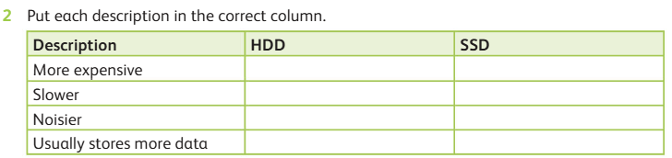
2) [2]

