1. Fig. 1.1 is a diagram of the human female reproductive system.

(i) Complete Table 6.1 by stating the letter from Fig. 6.1 that identifies the structure where

each process occurs.

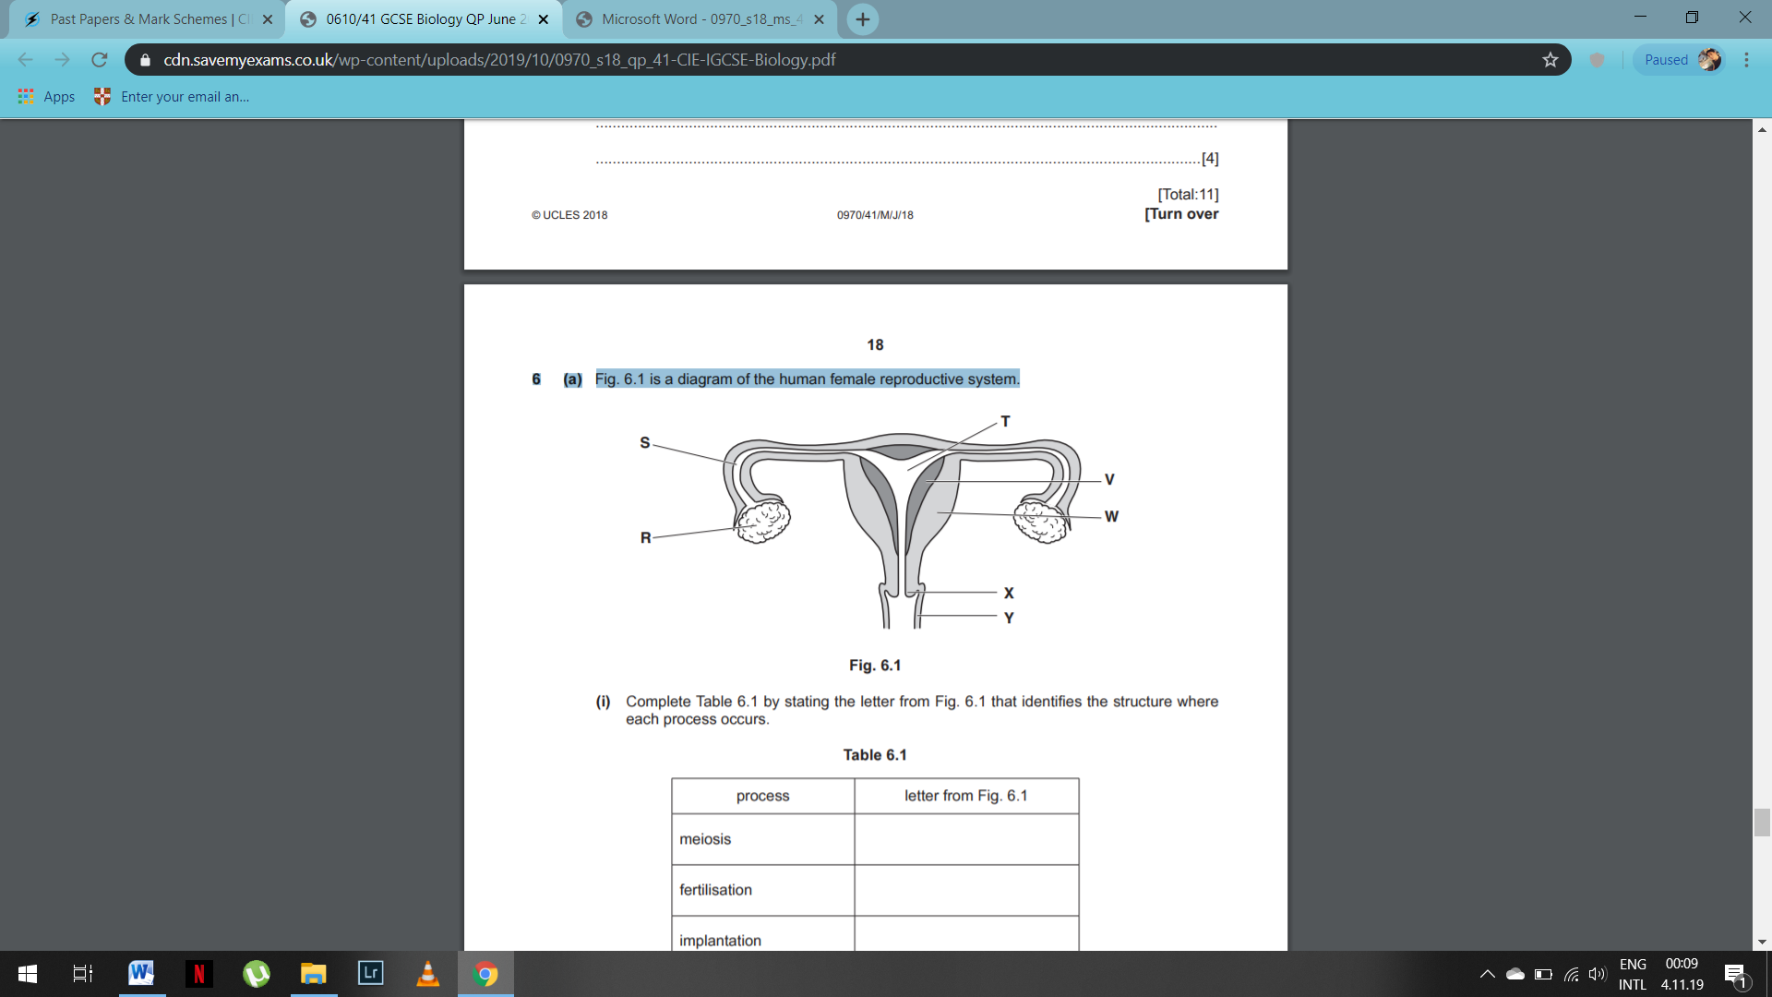

Fig. 1.1

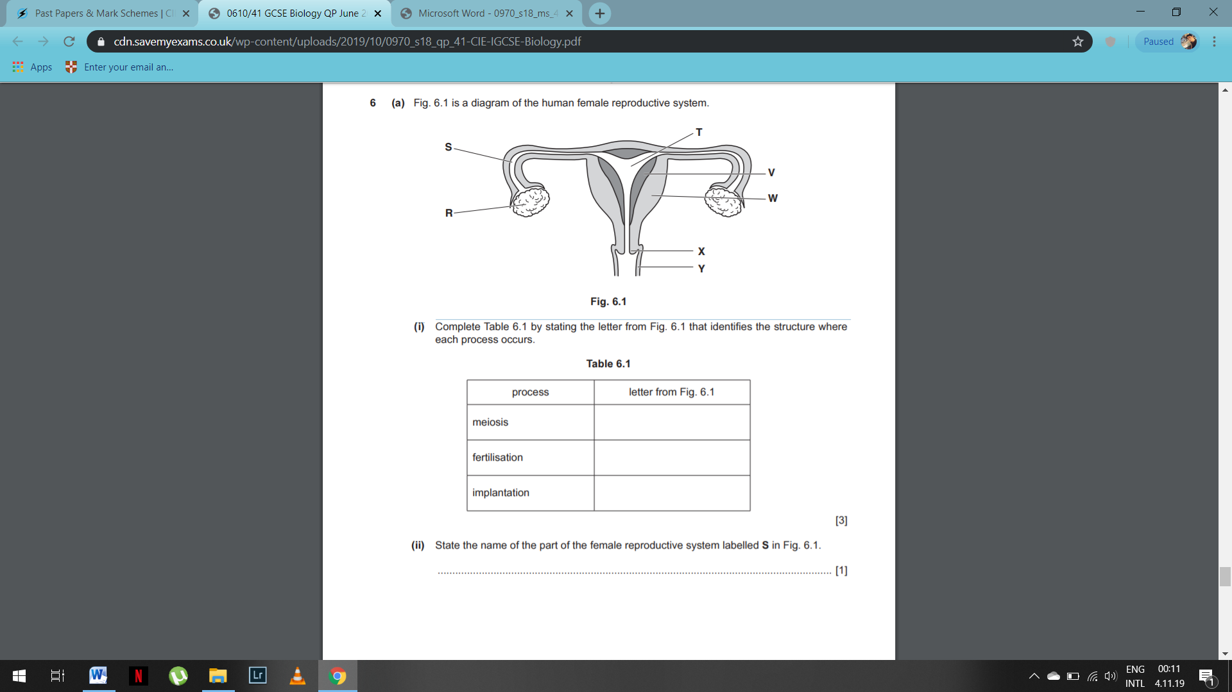

(ii) State the name of the part of the female reproductive system labelled S in Fig. 1.1.

...................................................................................................................................... [1]

1. Explain why the nuclei of sperm cells differ from those of other cells in the male.

...................................................................................................................................................

...................................................................................................................................................

...................................................................................................................................................

...............................................................................................................................................[2]

1. Explain the roles of the flagellum, the mitochondria and the acrosome in sperm cells.

...................................................................................................................................................

...................................................................................................................................................

...................................................................................................................................................

...................................................................................................................................................

...................................................................................................................................................

...................................................................................................................................................

...................................................................................................................................................

...................................................................................................................................................

...................................................................................................................................................

...................................................................................................................................................

...................................................................................................................................................

...................................................................................................................................................

...............................................................................................................................................[4]