Symmetry – Reflective and Rotational – Mathematical Shapes
Describe the symmetry of the mathematical shapes below, drawing on lines of symmetry where necessary and giving the order of rotational symmetry:
 | Shape | Reflective | Rotational
1 | 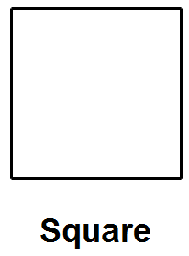
2 | 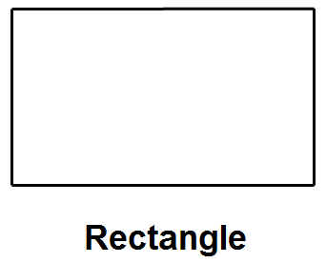
3 | 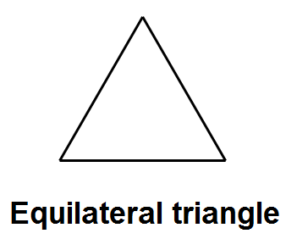
4 | 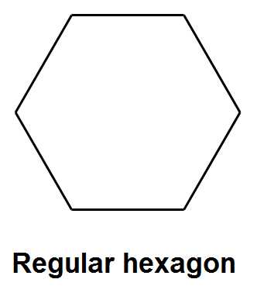
5 | 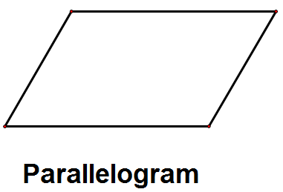

Symmetry – Reflective and Rotational – Other Shapes
Describe the symmetry of the shapes below, drawing on lines of symmetry where necessary and giving the order of rotational symmetry:
 | Shape | Reflective | Rotational
1 | 
2 | 
3 | 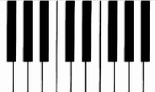
4 | 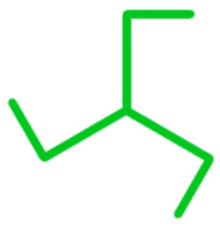
5 | 

Drawing a Symmetrical Diagram
Complete the diagrams below given their properties of symmetry:
Question | Shape
Shade three more squares to create a shape with one line of symmetry: | 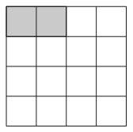
Shade three more squares to create a shape with rotational symmetry order 2: | 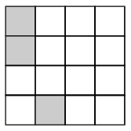
Shade four more triangles to create a shape with three lines of symmetry: | 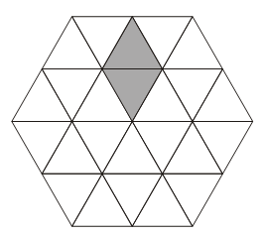
Shade six more triangles to create a shape with rotational symmetry order 3: | 