Sulphur Picture:

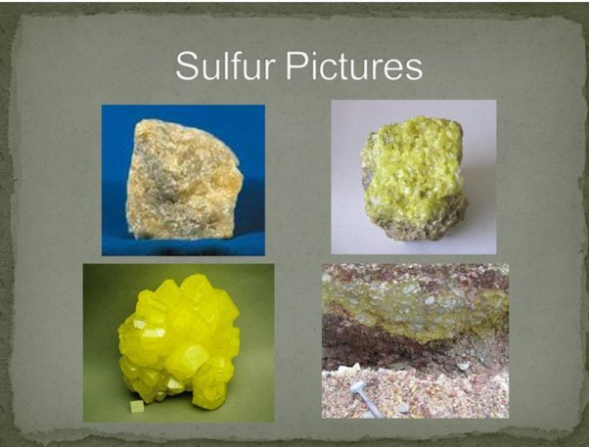

sulfur (S), also spelled sulphur, nonmetallic chemical element belonging to the oxygen group (Group 16 [VIa] of the periodic table), one of the most reactive of the elements. **Pure sulfur is a tasteless, odourless, brittle solid** that is pale yellow in colour, a poor conductor of electricity, and insoluble in water.

Frasch process of sulphur:

<https://www.youtube.com/watch?v=yVuyXxsmdUI>

Uses of sulphur:

<https://www.youtube.com/watch?v=rKZFkD7bPpo>

**QATARGAS’ COMMON SULFUR PLANT ACHIEVES HISTORIC PROCESSING MILESTONE**

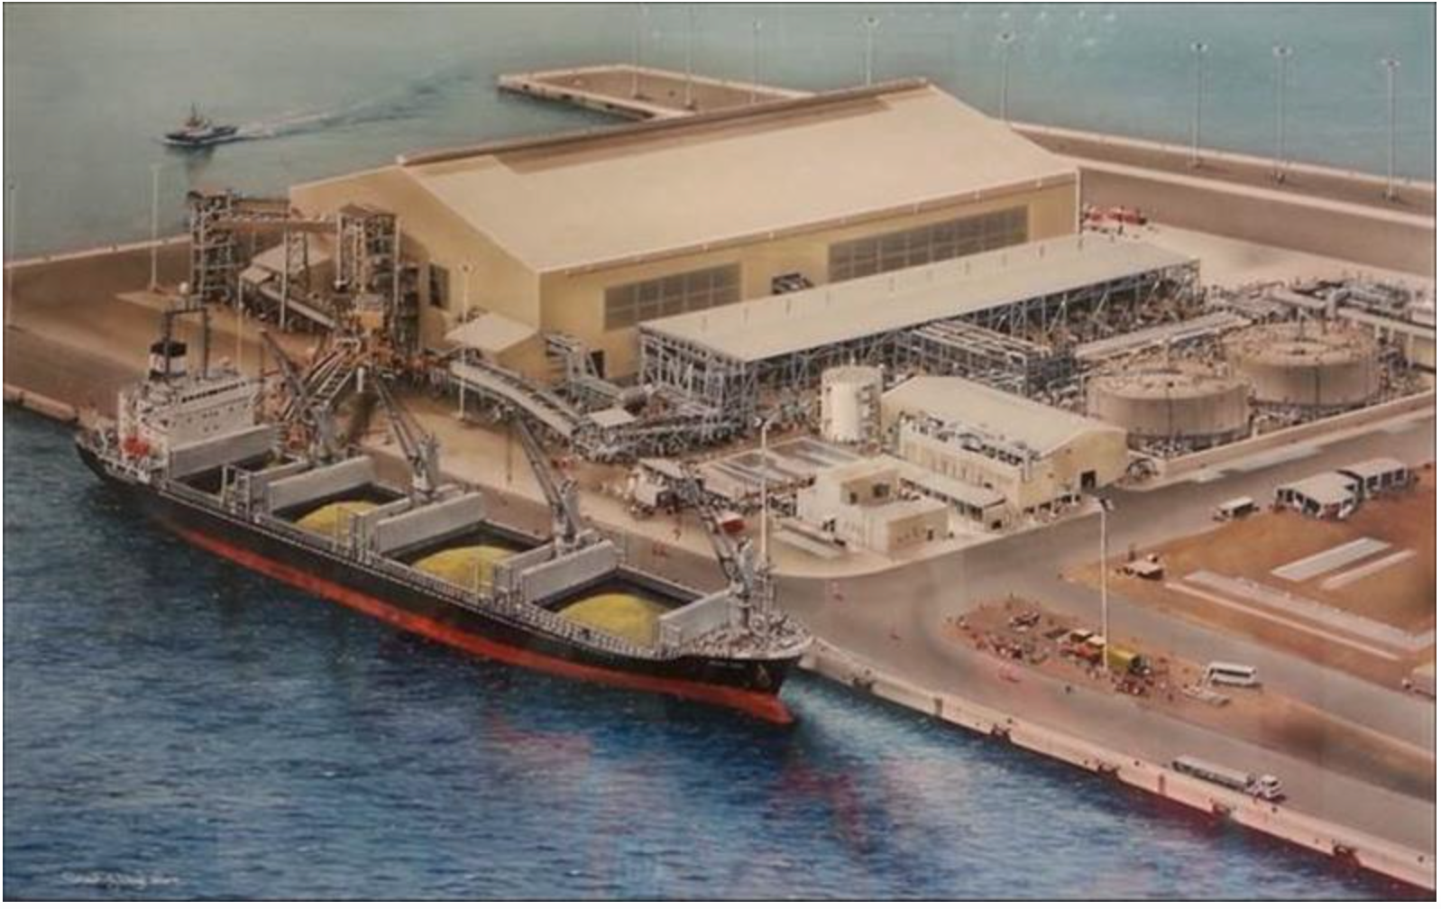

**CSP, located in Ras Laffan Industrial City, serves as one of the world's largest sulfur processing plants**. Sulfur is extracted in liquid form from natural gas that flows from the North Field into multiple gas plants based in Ras Laffan

Natural Gas creating to production:

<https://www.youtube.com/watch?v=9eV1cULsdO4>

Industrial processes in Qatar:

<https://www.youtube.com/watch?v=ZNSrCoqjV7w>

This is the latest documentary on Ras Laffan Industrial City (RLC), the base for all onshore operations to support the development and utilization of Qatar's North Field gas assets. RLC provides industries with land, roads and common corridors for pipelines, and other utilities' structures. The Port of Ras Laffan, which is the largest LNG export facility in the world, facilitates the marine export of all the hydrocarbons and sulphur produced by industries, the import of general cargo, and the support of offshore production operations in the North Field.

How can planstic made from oil:

<https://www.youtube.com/watch?v=IwdUwffecsM>

The age of metails:

<https://www.youtube.com/watch?v=4QMlLsRS7vY>

Copper ore for kids:

<https://www.youtube.com/watch?v=3nneL6zDEMA>

copper facts for kids:

<https://www.youtube.com/watch?v=xgxvPPrlc9w>