1a. **Create a chart** to compare the male and female populations across the different age groups.

**If the bar chart or column charts are created the way mentioned below. Learner will get 1 marks.**

1b. **Label your chart**:

* X-axis: Age Groups
* Y-axis: Population
* Add a chart title: *“Population by Age Group and Gender in Qatar”*.

**All these labels in the chart carry 3 marks(1 mark each label).**

1c. Customize the chart by giving different colors to male and female populations.   
Different color schemes will get them 1 mark in this section.

[5]

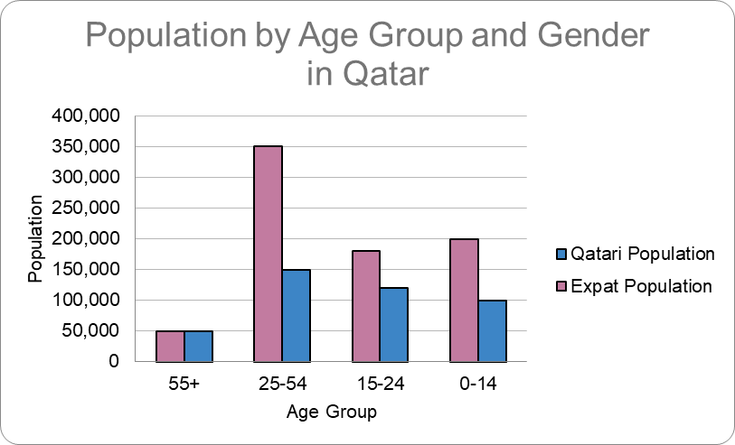

**2. Create a chart** to represent the percentage distribution of the Qatari and Expat population for the 0-14 age group.

* Add data labels showing percentages.
* **Customize** the chart by making the Qatari segment stand out with a different color.
* Add a chart title: *“Population Distribution for Age Group 0-14”*.

[4]  
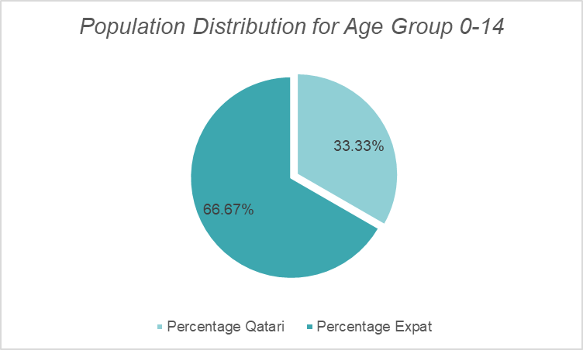

**3. Create a graph** to show the trend of the total population across the different age groups.

* Label the X-axis as "Age Group" and the Y-axis as "Total Population".
* Add a chart title: *“Population Trend by Age Group”*.
* **"Add Major Gridlines"** for both the X-axis and Y-axis.

[4]

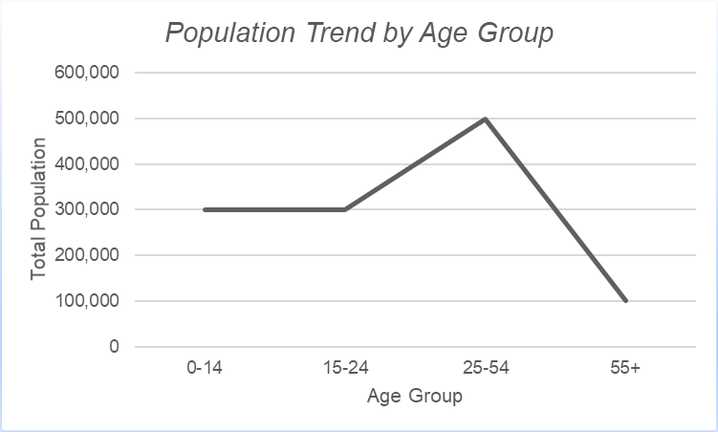

4. Create a graph to compare the total Qatari population with the percentage of the Qatari population across different age groups?

[2]

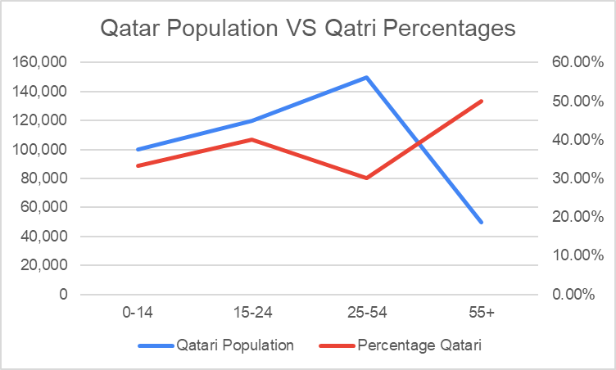

Evidence screenshot:  
