|  |  |
| --- | --- |
|  |  |
| **Exact Trig Values - Worksheet** | |

# Skill

**Group A - Sine**

Write down the exact trig values for:

**1)** sin(0) **2)** sin(30) **3)** sin(45)

**4)** sin(60) **5)** sin(90)

# Group B - Cosine

Write down the exact trig values for:

**1)** cos(0) **2)** cos(30) **3)** cos(45)

**4)** cos(60) **5)** cos(90)

# Group C - Tangent

Write down the exact trig values for:

**1)** tan(0) **2)** tan(30) **3)** tan(45)

**4)** tan(60)

# Applied

1. **(a)** Find the exact value of cos(0) + sin(90).
   1. Find the exact value of cos(30) + sin(60).
2. **(a)** Find the exact value of tan(45) + sin(45). Write your answer as a single fraction.
   1. Find the exact value of sin(30) + tan(60). Write your answer as a single fraction.
3. **(a)** Find the exact value of 4 cos(60).
   1. Find the exact value of 15 tan(30).
4. 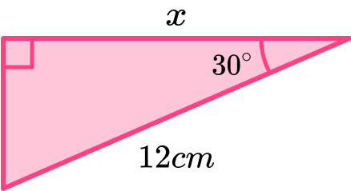**(a)** Use trigonometry in the diagram below to show that 𝑥 = 6

3

* 1. 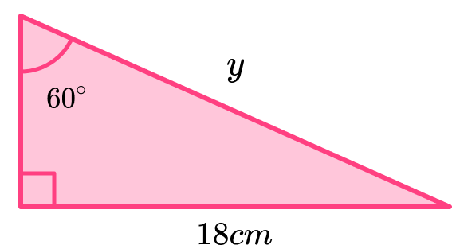Use trigonometry in the diagram below to show that 𝑦 = 12

3

1. What is the exact value of tan(30)? Circle your answer.

|  |  |  |
| --- | --- | --- |
| 2 | 1 | 3 |
| 2 | 2 | 3 |

3

# (1 mark)

1. Calculate the exact value of sin(60) + tan(60). Simplify your answer by writing it as a single term.

….……………

# (2 marks)

1. Use trigonometry to show that AB is 8 3. Diagram NOT to scale.

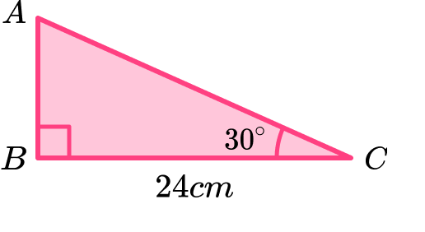

….……………

# (2 marks)

1. The diagram shows a right-angled triangle.

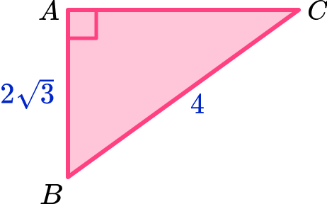 Diagram NOT to scale.

Use trigonometry to show that angle ABC is 45◦.

….……………

# (2 marks)

**Exact Trig Values - Answers**

|  |  |  |
| --- | --- | --- |
|  | **Question** | **Answer** |
|  | **Skill Questions** |  |
| **Group A** | Write down the exact trig values for: |  |
|  | **1)** sin(0) | **1)** 0 |
|  | **2)** sin(30) | **2)**  1  2 |
|  | **3)** sin(45) | **3)**  2 (or 1 ) |
|  |  | 2 2 |
|  | **4)** sin(60) | **4)**  3  2 |
|  | **5)** sin(90) | **5)** 1 |
| **Group B** | Write down the exact trig values for: |  |
|  | **1)** cos(0) | **1)** 1 |
|  | **2)** cos(30) | **2)**  3  2 |
|  | **3)** cos(45) | **3)**  2 (or 1 ) |
|  |  | 2 2 |
|  | **4)** cos(60) | **4)**  1  2 |
|  | **5)** cos(90) | **5)** 0 |
| **Group C** | Write down the exact trig values for: |  |
|  | **1)** tan(0) | **1)** 0 |
|  | **2)** tan(30) | **2)**  3 (or 1 ) |
|  |  | 3 3 |
|  | **3)** tan(45) | **3)** 1 |
|  | **4)** tan(60) | **4)** 3 |

|  |  |
| --- | --- |
|  |  |
| **Exact Trig Values - Answers** | |

|  |  |  |  |
| --- | --- | --- | --- |
|  | **Question** | **Answer** | |
|  | **Applied Questions** |  | |
| **1)** | 1. Find the exact value of cos(0) + sin(90). 2. Find the exact value of cos(30) + sin(60). | **a)**  **b)** | 1 + 1 = 2  3 + 3 = 3  2 2 |
| **2)** | 1. Find the exact value of tan(45) + sin(45). Write your answer as a single fraction. 2. Find the exact value of sin(30) + tan(60). Write your answer as a single fraction. | **a)**  **b)** | 1 + 2 = 2+ 2  2 2  1 + 3 = 1+2 3  2 2 |
| **3)** | 1. Find the exact value of 4 cos(60). | **a)** | 4 ×  1 = 2  2 |
|  | **b)** Find the exact value of 15 tan(30). | **b)** | 15 × 3 = 5 3  3 |
| **4)** | 1. Use trigonometry in the diagram below to show that 𝑥 = 6 3  1. Use trigonometry in the diagram below to show that 𝑦 = 12 3 | 1. cos(θ) = 𝐴𝑑𝑗𝑎𝑐𝑒𝑛𝑡   𝐻𝑦𝑝𝑜𝑡𝑒𝑛𝑢𝑠𝑒  cos(30) = 𝑥  12  𝑥 = 12 × cos(30)  = 12 × 3 = 6 3  2   1. sin(θ) = 𝑂𝑝𝑝𝑜𝑠𝑖𝑡𝑒   𝐻𝑦𝑝𝑜𝑡𝑒𝑛𝑢𝑠𝑒  sin(60) =  18  𝑦  𝑦 = 18 ÷ sin(60)  = 18 ÷ 3 = 12 3  2 | |

|  |  |
| --- | --- |
| GCSE Maths Revision | Geometry and Measure |  |
| **Exact Trig Values - Mark Scheme** | |

|  |  |  |  |
| --- | --- | --- | --- |
|  | **Question** | **Answer** | |
|  | **Exam Questions** |  | |
| **1)** | What is the exact value of tan(30)? Circle your answer.  2 1 3 3  2 2 3 | 3 3 | **(1)** |
| **2)** | Calculate the exact value of sin(60) + tan(60). | 3 + 3 | **(1)** |
|  | Simplify your answer by writing it as a single term. | 2  = 3 3  2 | **(1)** |
| **3)** | Use trigonometry to show that AB is 8 3 𝑐𝑚 .  Diagram NOT to scale. | tan(θ) = 𝑂𝑝𝑝𝑜𝑠𝑖𝑡𝑒  𝐴𝑑𝑗𝑎𝑐𝑒𝑛𝑡  tan(30) = 3  3  𝐴𝐵 = 24 × 3 = 8 3  3 | **(1)**  **(1)** |
| **4)** | The diagram shows a right-angled triangle.  Diagram NOT to scale. Use trigonometry to show that ABC is 45◦. | cos(θ) = 𝐴𝑑𝑗𝑎𝑐𝑒𝑛𝑡  𝐻𝑦𝑝𝑜𝑡𝑒𝑛𝑢𝑠𝑒  cos(𝐴𝐵𝐶) = 2 3 = 3  4 2  cos(45) = 3  2  So ABC is 45𝑜 | **(1)**  **(1)** |

***Do you have KS4 students who need additional support in maths?***

Our specialist tutors will help them develop the skills they need to succeed at GCSE in weekly one to one online revision lessons. Trusted by secondary schools across the UK.

Visit **thirdspacelearning.com** to find out more.