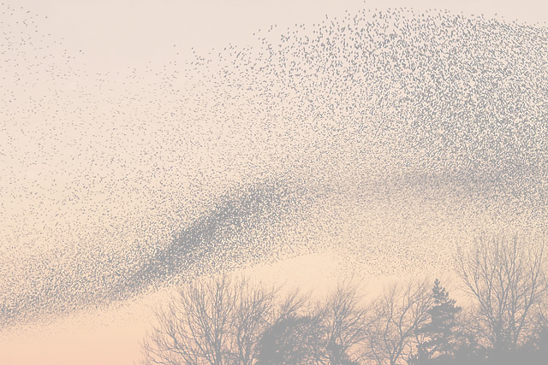**Three punctuation rules**

1. **Always start a sentence with a capital letter. A question should start with a question word (how, what, where etc.) and an exclamation should start with ‘what’ or ‘how’.**
2. **Always finish a sentence with a full stop, a question mark or an exclamation mark.**
3. **Use commas to create pauses in sentences or to separate things in a lists.**

Unit 4 Day 1

**Starling**

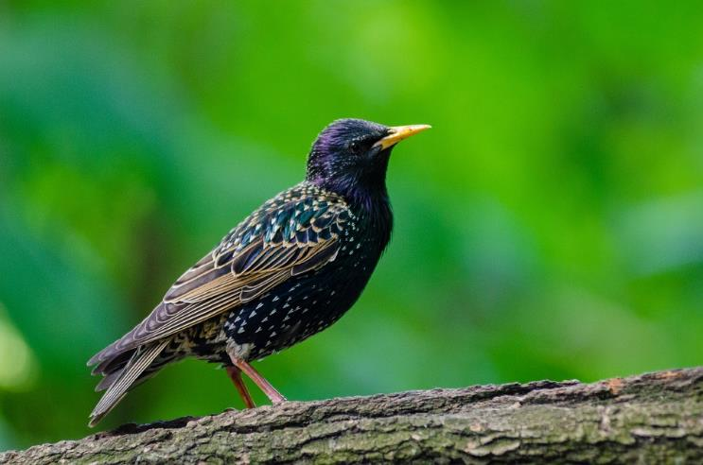

Unit 4 Day 1

**The Starlings (an extract)**

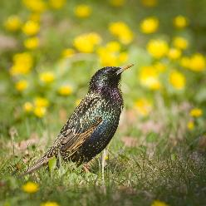They are tightly bunched together there among the leaves;

And the hundreds of thousands of starlings

That perform their flying exercises

Against the backdrop of the evening's mass of motionless cloud

Will surely soon have lost their places:

There are myriads of swarming punctuation marks out there,

Starlings flying in formation,

Sudden sharp turns, steep ascents,

Swarm on delightful swarm

Against a rosy cloud bank in the east.

*Jesper Svenbro*

Motionless means *not moving*.

Myriad means *too many to count*.

Unit 4 Day 1

**Starling Questions (a)**

*Punctuate these questions about starlings using a coloured pencil.*

1. how many flying neighbours do starlings need to be aware of at any one time
2. how many flying rules must a starling follow in relation to its neighbour
3. what should a starling do if one of its neighbours turns
4. how close should starlings fly to each other
5. what is the impact of a murmuration on a predator

*Use statements to answer the questions.*

1. **____________________________________**
2. **____________________________________**
3. **____________________________________**
4. **____________________________________**
5. **____________________________________**

*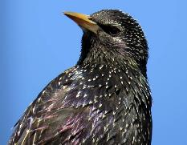***Challenge:**Write another question and answer about starlings.

Unit 4 Day 1

**Starling Questions (b)**

Punctuate these questions about starlings.

1. how many flying neighbours do starlings need to notice
2. how many flying rules does a starling follow
3. 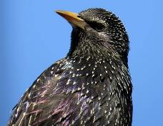what should a starling do if one of its neighbours turns
4. what is a murmuration

*Use statements to answer at least three of the questions.*

1. **____________________________________**
2. **____________________________________**
3. **____________________________________**
4. **____________________________________**

**Challenge:** write one more question and answer about starlings.

Q.______________________________________________________________

A.______________________________________________________________

Unit 4 Day 1

**Starling Questions (a) ANSWERS**Punctuate these questions about starlings using a coloured pencil.

1. How many flying neighbours do starlings need to be aware of at any one time?
2. How many flying rules must a starling follow in relation to its neighbour?
3. What should a starling do if one of its neighbours turns?
4. How close should starlings fly to each other?
5. What is the impact of a murmuration on a predator?

Answer the questions below, using statements.

1. *Starlings need to be aware of their seven closest neighbours.*
2. *There are three flying rules that Starlings should follow.*
3. *If a starling’s neighbour turns, it should turn as well.*
4. *Starlings should fly close by their neighbours but shouldn’t crowd them.*
5. *Starling murmurations confuse predators.*

Unit 4 Day 1

**Starling Questions (b) ANSWERS**Punctuate these questions about starlings using a coloured pencil.

1. How many flying neighbours do starlings need to notice?
2. How many flying rules does a starling follow?
3. What should a starling do if one of its neighbours turns?
4. What is a murmuration?

Answer the questions below, using statements.

1. *Starlings need to notice their seven closest neighbours.*
2. *There are three flying rules that starlings should follow.*
3. *If a starling’s neighbour turns, it should turn as well.*
4. *A murmuration is a huge group of starlings flying.*

Unit 4 Day 1