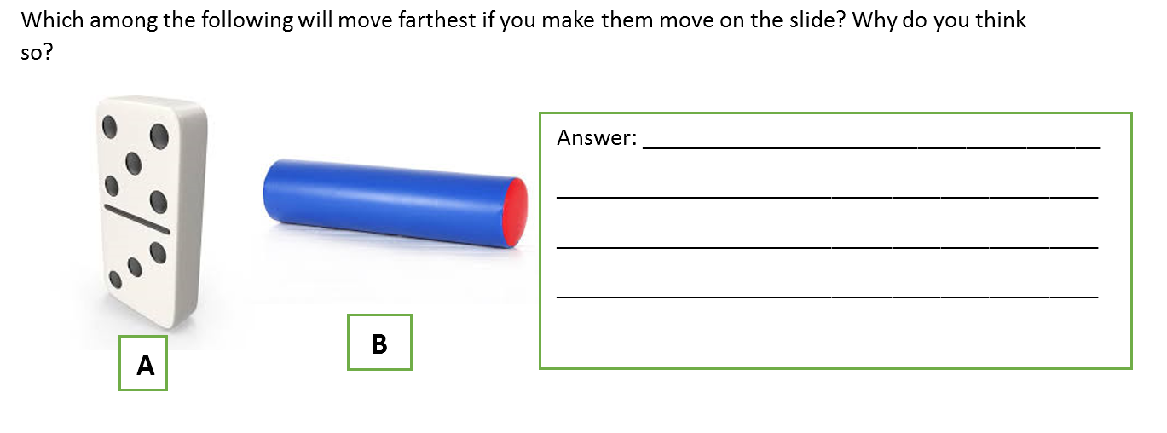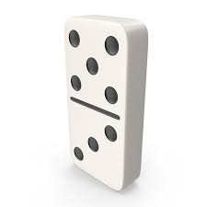Which among the following will move farthest if you make them move on the slide? Why do you think so?

Answer: ______________________________________

­­­­­­­­­­­­­­­­_____________________________________________

_____________________________________________

_____________________________________________

**B**

**A**