Group 3-

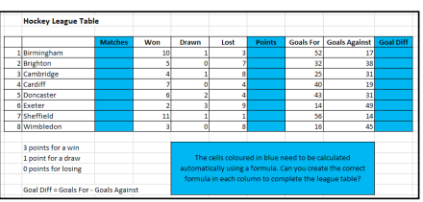

* Students will create a given spreadsheet on the teachers laptop or on MS Excel of the smart board.
* Using the information, they will create the table with field attributes specifying the data item field name and data type.
* They will calculate total matches each team played, total points and goal differences from the given hint. (Autosum Forumla/Addition)
* After completing this task, they will explain and demostrate how to find the phrase using the excel sheet.
* They will present thhis work in front of the class.