Discuss with your group and complete the task.

Scenario 1-

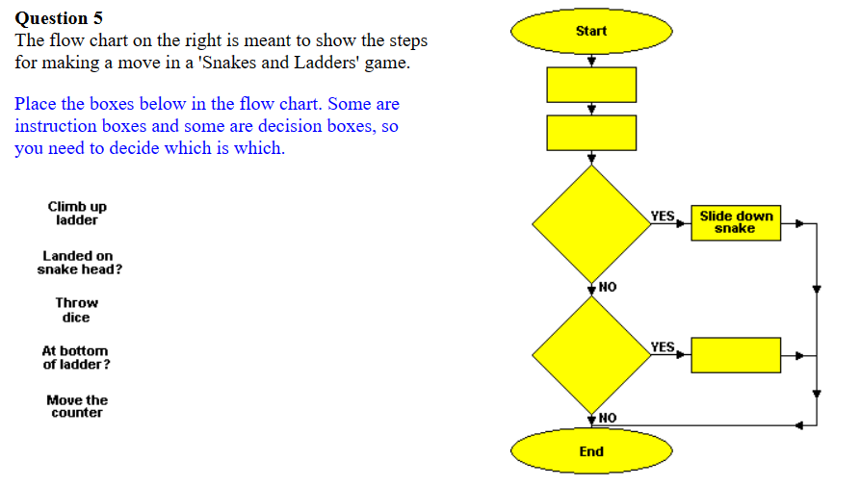

a) Find out the flowchart name-_________________________

b)List the symbols used to represent the algorithm-

___________________________________________________________________

___________________________________________________________________

___________________________________________________________________

___________________________________________________________________

___________________________________________________________________

Scenario 2-

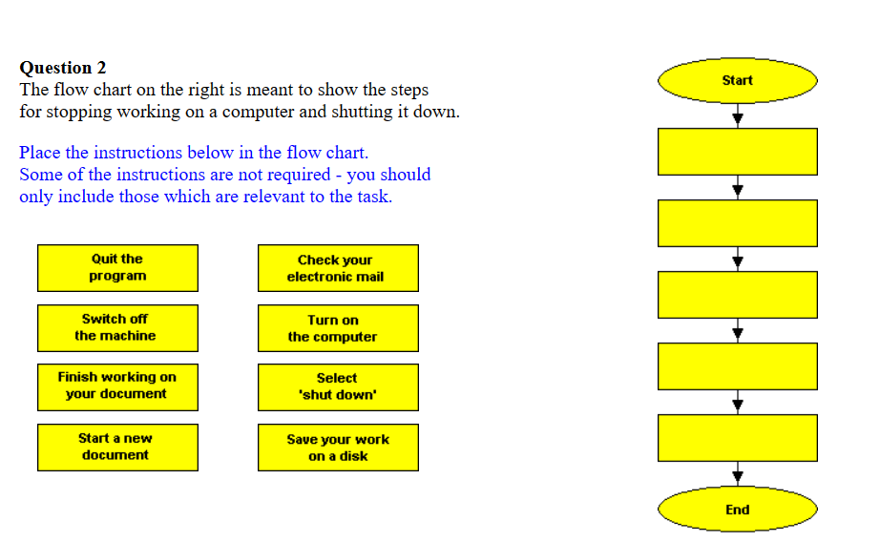

a) Find out the flowchart name-_________________________

b) List the symbols used to represent the algorithm-

___________________________________________________________________

___________________________________________________________________

___________________________________________________________________

___________________________________________________________________

___________________________________________________________________