Discuss with your group and complete the task.

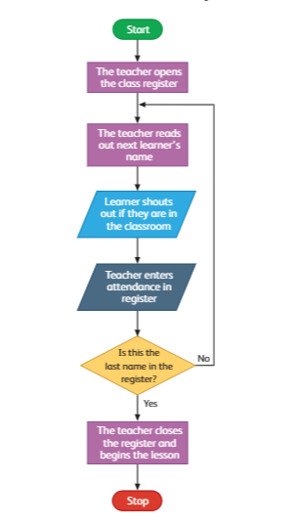Scenario 1-

a) Predict the outcome-_________________________

___________________________________________________________________

___________________________________________________________________

___________________________________________________________________

___________________________________________________________________

___________________________________________________________________

b) Label each the symbols.

Scenario 2-

Read and understand the algorithm

|  |  |
| --- | --- |
| Steps | Instruction |
| 1 | Users enters the num =1 and sum=0 |
| 2 | If number <=50 True |
| 3 | Sum=sum+num and num=num+1 |
| 5 | If false then output is sum |
| 6 | End |

Predict the outcome-

___________________________________________________________________

___________________________________________________________________

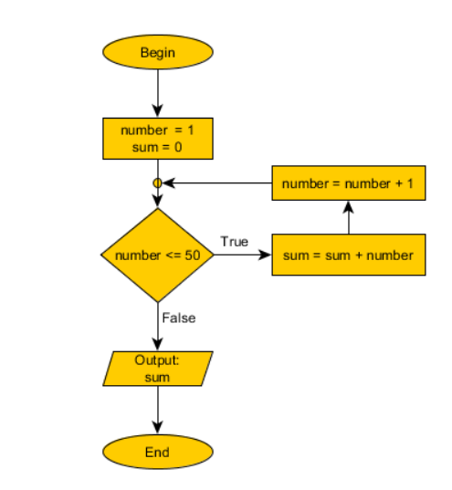Complete the flowchart and label the input, output and process.