**Task A: Creating a Game in ScratchJr**

1: Open Scratch on your computer.

2. Create a new project.

3. Add a Frog character to your project. here is the algorithm for the Frog:

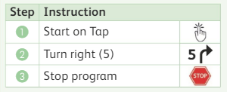

4. Write down the corresponding code in Scratch.

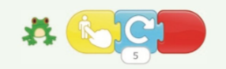

5. Run the program and observe if the code matches the algorithm.

6. Add a Snake character to your project. Here is the algorithm for the Snake:

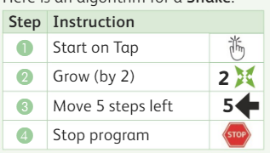 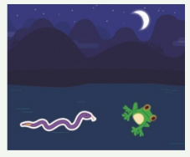

7.Write down the corresponding code in Scratch for snake .



8. Test the code and observe if the program gives the right result.

9. Debug the code if necessary by identifying and fixing any errors.

10. Run the program again to ensure it works correctly.