1) Take a look at the two images below. One of the ladies is quite comfortable, but the other one might have some aches and pains if she spends too long in that position. Which one is correct?

_______________________________________________________________________________________

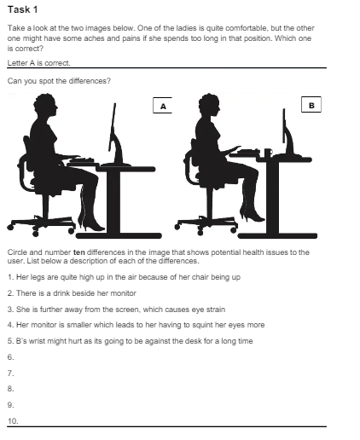

2) Circle and number ten differences in the image that shows potential health issues to the user. List below a description of each of the differences.

1._________________________________________________________________

2. _________________________________________________________________

3. _________________________________________________________________

4._________________________________________________________________

5. _________________________________________________________________

6._________________________________________________________________

7._________________________________________________________________

8._________________________________________________________________

9._________________________________________________________________

10._________________________________________________________________