Exit Ticket
Look at the following diagram and describe fully the single transformation that maps one shape on to another.
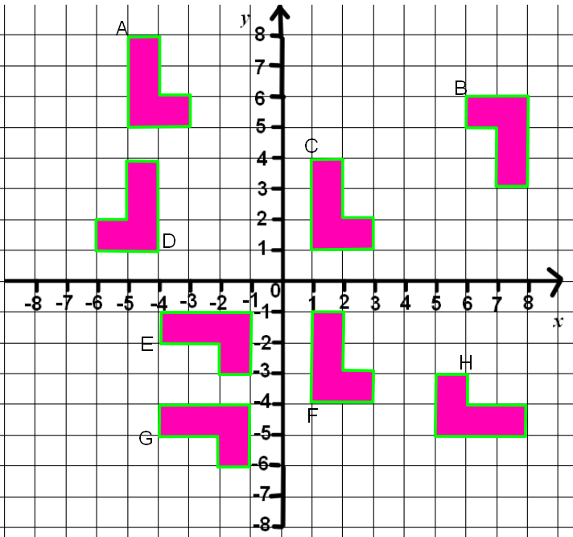

A to C ………………………………………………………

C to D …………………………………………………..

C to E…………………………………………………..

