This table shows the marks of student in various subjects.

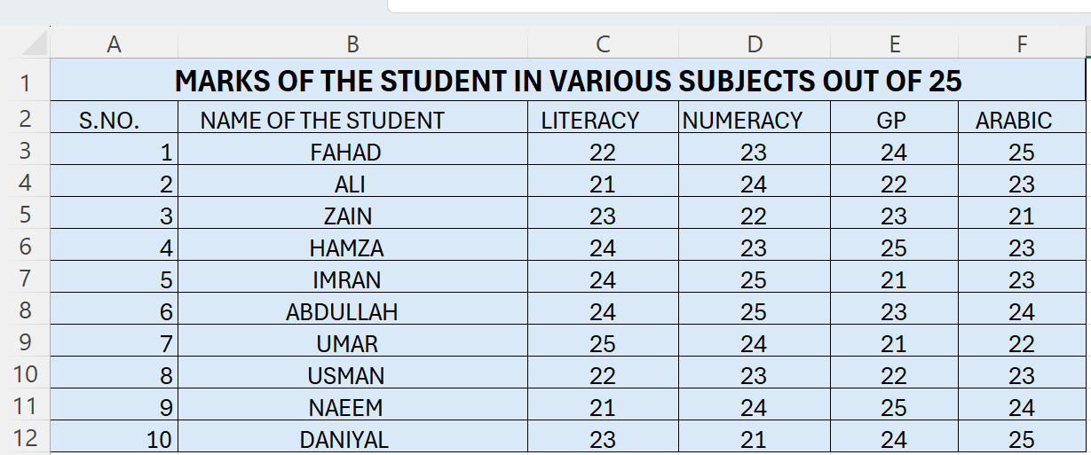
a. Open MS Excel.
b. Create above spreadsheet in excel.
c. Which type of data is seen in the table? _____________________
d. Insert the best suitable chart that fits to this data.
e. Save your document as Yourname-Class.
RUBRIC FOR CREATING SPREADSHEET AND INSERTING CHART.
 | 1 | 2 | 3
Able to insert spreadsheet
Able to identify data type
Able to insert chart in excel
Able to Save
Key:
- Needs more opportunity to develop this skill.
- Beginning to demonstrate this skill.
- Has achieved this skill.

