Revision- Algorithm design and problem solving
1. | Describe one type of test data that must be used to test if a program accepts valid input data.  ..........................................................................................................................................................  ..........................................................................................................................................................  ..........................................................................................................................................................  ..........................................................................................................................................................[2]
2. | A satellite navigation system is an example of a computer system that is made up of sub-systems.  Part of a satellite navigation system:  Allows the user to enter details for a new destination or select a previously saved destination  Displays directions in the form of a visual map or as a list.  Draw a structure diagram for this part of the satellite navigation system.  [4]
3. | Tick one box in each row to identify if the statement is about validation, verification or neither.  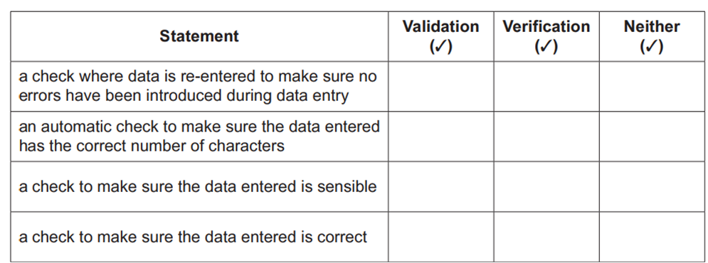 [3]
4. | The energy efficiency of an electrical appliance is the percentage of useful energy out compared with the total energy in.  An algorithm has been written in pseudo-code to calculate the energy efficiency of an appliance.  Values for total energy in and useful energy out are inputs. The efficiency is calculated and output as a percentage.  The entry of a number -1 for either value stops the algorithm.  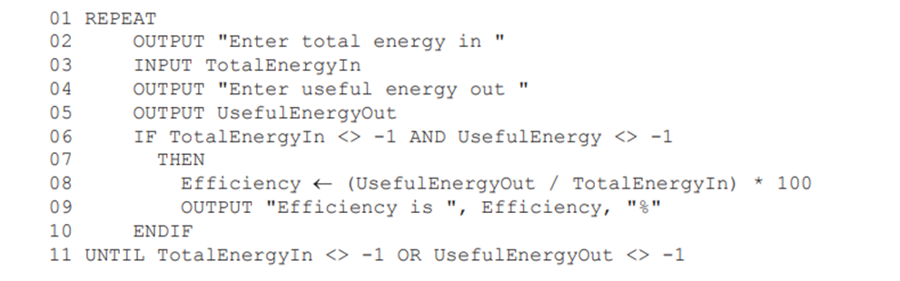  - Identify the three errors in the pseudocode and suggest corrections.  Error 1 …………………………………………………………………………………….  Correction …………………………………………………………………………………  …………………………………………………………………………………………….  Error 2 …………………………………………………………………………………….  Correction …………………………………………………………………………………  …………………………………………………………………………………………….  Error 3 …………………………………………………………………………………….  Correction …………………………………………………………………………………  ……………………………………………………………………………………………. [3]
5. | Identify the purpose of the following algorithm.  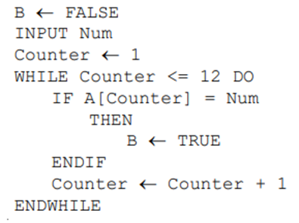  ………………………………………………………………………………………………………  ………………………………………………………………………………………………………. [1]

