Investigating shadow lengths

Viola, Sophie and Shruti like to sit on a bench under a palm tree during school breaks.

The girls measured the length of the shadow cast by the palm tree at different times of the day.   
Here are their results:

|  |  |  |  |  |
| --- | --- | --- | --- | --- |
| **Time of day** | 10:00 | 12:00 | 14:00 | 16:00 |
| **Length of shadow in cm** | 100 | 20 | 110 | 210 |

1 Record the results as a dot-to-dot graph.

|  |  |  |  |  |  |  |  |  |  |  |  |  |  |  |  |  |  |  |  |
| --- | --- | --- | --- | --- | --- | --- | --- | --- | --- | --- | --- | --- | --- | --- | --- | --- | --- | --- | --- |
|  |  |  |  |  |  |  |  |  |  |  |  |  |  |  |  |  |  |  |  |
|  |  |  |  |  |  |  |  |  |  |  |  |  |  |  |  |  |  |  |  |
|  |  |  |  |  |  |  |  |  |  |  |  |  |  |  |  |  |  |  |  |
|  |  |  |  |  |  |  |  |  |  |  |  |  |  |  |  |  |  |  |  |
|  |  |  |  |  |  |  |  |  |  |  |  |  |  |  |  |  |  |  |  |
|  |  |  |  |  |  |  |  |  |  |  |  |  |  |  |  |  |  |  |  |
|  |  |  |  |  |  |  |  |  |  |  |  |  |  |  |  |  |  |  |  |
|  |  |  |  |  |  |  |  |  |  |  |  |  |  |  |  |  |  |  |  |
|  |  |  |  |  |  |  |  |  |  |  |  |  |  |  |  |  |  |  |  |
|  |  |  |  |  |  |  |  |  |  |  |  |  |  |  |  |  |  |  |  |
|  |  |  |  |  |  |  |  |  |  |  |  |  |  |  |  |  |  |  |  |
|  |  |  |  |  |  |  |  |  |  |  |  |  |  |  |  |  |  |  |  |

2 Complete these sentences to describe the pattern in the results.

In the morning the shadow became __________. After midday the shadow became __________.

Help sheet

Use the axes below to help you draw the graph.

Give the graph a suitable title.

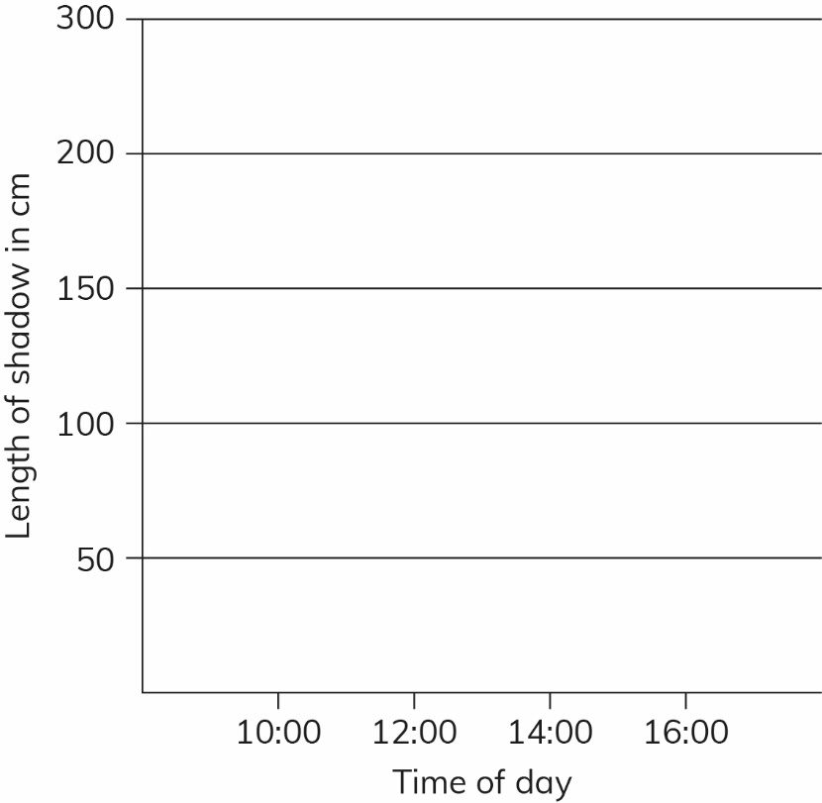

Rate your skills at drawing a dot-to-dot graph.

|  |  |  |  |
| --- | --- | --- | --- |
| **How well can I:** | **Very well**  **\*\*\*** | **Most of the time**  **\*\*** | **Not confident yet**  **\*** |
| decide what to put on each axis? |  |  |  |
| label the axes correctly? |  |  |  |
| decide on suitable scales on the axes? |  |  |  |
| draw the dots accurately? |  |  |  |
| join the dots neatly? |  |  |  |
| give the graph a suitable title? |  |  |  |