

TERM II

REVISION EXAMINATION

JUNE

2023-2024

Key Stage 3 (Year VIII____)

Date :  **May 2024**

Name of the Candidate : _________________________________________________________

Subject : ICT Paper 1 - THEORY

Maximum Marks : 80

Instructions to the candidate:

* The Exam is for 1 hr 30 minutes.
* Read the instructions carefully.
* Please make sure you have all the stationery items.
* Write in dark blue or black pen.
* You may use a soft pencil for any diagrams, graphs or rough work.
* Do not use staples, paper clips, highlighters, glue or correction fluid.
* No marks will be awarded for using the brand names of software packages or hardware.
* Answer all questions.
* At the end of the examination, fasten all your work securely together.
* The number of marks is given in brackets [ ] at the end of each question or part question.

|  |  |  |
| --- | --- | --- |
|  | **Maximum Marks** | **Marks Obtained** |
| **A** | **22** |  |
| **B** | **41** |  |
| **C** | **17** |  |
| **TOTAL** | **80** |  |

Checked by : ____________________________

Rechecked by : ____________________________

**SECTION A**

1. Circle two network devices.

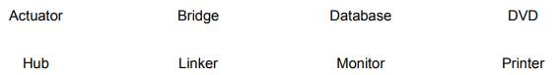 [2]

1. Tick (✓) whether the following are examples of internal or external hardware devices.

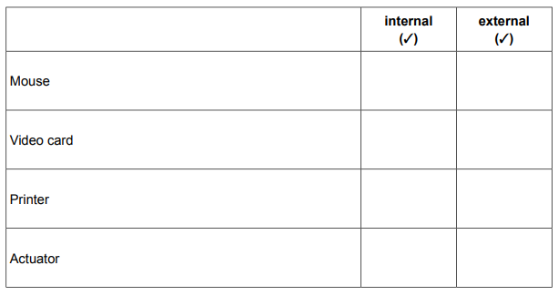 [2]

1. Complete each sentence using the most appropriate item from the list. Your answers must be different in each case.

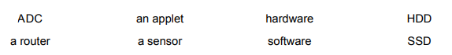

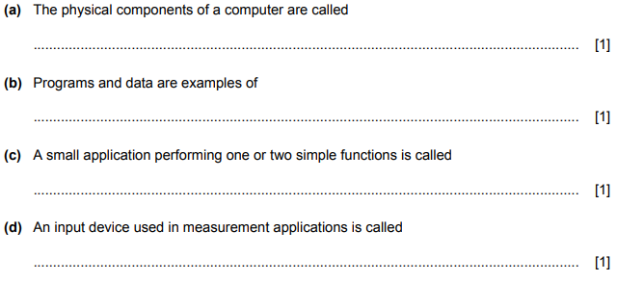

1. Geeta spends a great deal of time at work entering data into her computer. State three items of hardware that Geeta should be provided with to help avoid RSI when she enters data into the computer.

1........................................................................................................................................................................................................................................................................................................................... 2 ............................................................................................................................................................ ............................................................................................................................................................... 3……………..................................................................................................................................................................................................................................................................................................... [3]

1. Many laptop computers use the cloud to store data.

A technician has produced a report on his laptop computer but has stored the report on a memory stick rather than storing it on the cloud.

Describe two advantages of using a memory stick rather than the cloud to store data.

1............................................................................................................................................................................................................................................................................................................................ 2 ............................................................................................................................................................ .......................................................................................................................................................... [2]

1. Network devices are used in computer systems. Complete each sentence by identifying the most appropriate network device.

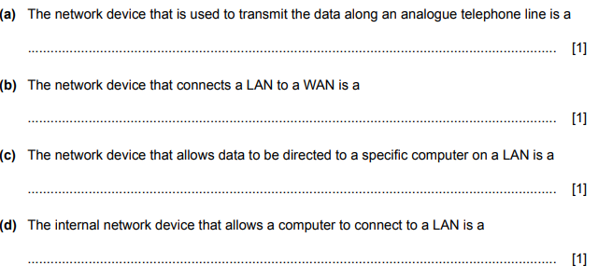

1. Laptop computers use Solid State Drives (SSD) rather than Hard Disc Drives (HDD). Describe two disadvantages of using an SSD rather than an HDD in a laptop computer.

1............................................................................................................................................................................................................................................................................................................................

2........................................................................................................................................................................................................................................................................................................................[2]

1. Spam is associated with ICT systems.

Explain what is meant by the term spam.

...............................................................................................................................................................

.......................................................................................................................................................... [1]

1. Describe two issues related to the security of data in the cloud.

1...........................................................................................................................................................................................................................................................................................................................

2........................................................................................................................................................................................................................................................................................................................[2]

**SECTION B**

1. Emails are used by people to communicate with each other. Copyright and using acceptable language in the email are two of the constraints that affect the use of email.

(i) Describe four other constraints that may affect the use of email.

1...........................................................................................................................................................................................................................................................................................................................

2...........................................................................................................................................................................................................................................................................................................................

3...........................................................................................................................................................................................................................................................................................................................

4...................................................................................................................................................................................................................................................................................................................... [4]

(ii) Describe two rules of the use of acceptable language in emails.

1...........................................................................................................................................................................................................................................................................................................................

2....................................................................................................................................................................................................................................................................................................................... [2]

1. Explain what is meant by cloud storage and how it is used

..............................................................................................................................................................................................................................................................................................................................

..............................................................................................................................................................................................................................................................................................................................

..............................................................................................................................................................................................................................................................................................................................

..............................................................................................................................................................................................................................................................................................................................

..............................................................................................................................................................................................................................................................................................................................

..........................................................................................................................................................................................................................................................................................................................[6]

1. A parent is concerned about his children sending texts. When sending a text, it is important to follow netiquette.

(a) Explain what is meant by the term netiquette. ............................................................................................................................................................................................................................................................................................................................................................................................................................................................................................. .......................................................................................................................................................... [2]

(b) The parent is planning to produce a number of rules to ensure that his children follow netiquette when texting other people. Write down four rules that he could include in his list.

1............................................................................................................................................................................................................................................................................................................................ 2...........................................................................................................................................................................................................................................................................................................................3...........................................................................................................................................................................................................................................................................................................................4....................................................................................................................................................................................................................................................................................................................... [4]

1. When using computers people can suffer from Repetitive Strain Injury (RSI).

(a) Describe the term RSI. Include in your answer the causes of RSI. ..................................................................................................................................................................................................................................................................................................................................................................................................................................................................................................................................................................................................................................................................................................................................................................................................................................................................................................................................................................................... [3]

(b) Identify three methods of reducing the effects of RSI.

1............................................................................................................................................................................................................................................................................................................................2 ............................................................................................................................................................ ...............................................................................................................................................................3........................................................................................................................................................................................................................................................................................................................[3]

1. Explain the need for copyright legislation when data is published on the internet.

..............................................................................................................................................................................................................................................................................................................................

..............................................................................................................................................................................................................................................................................................................................

..............................................................................................................................................................................................................................................................................................................................

..........................................................................................................................................................................................................................................................................................................................[4]

1. A car manufacturing company uses computer-controlled robots to manufacture its cars. Discuss the advantages and disadvantages to the company of using computer-controlled robots rather than using humans to manufacture the cars.

..............................................................................................................................................................................................................................................................................................................................

..............................................................................................................................................................................................................................................................................................................................

..............................................................................................................................................................................................................................................................................................................................

..............................................................................................................................................................................................................................................................................................................................

..............................................................................................................................................................................................................................................................................................................................

..........................................................................................................................................................................................................................................................................................................................[6]

1. Describe the ways that a user can recognise spam and methods to help prevent it.

..............................................................................................................................................................................................................................................................................................................................

..............................................................................................................................................................................................................................................................................................................................

..............................................................................................................................................................................................................................................................................................................................

..............................................................................................................................................................................................................................................................................................................................

..............................................................................................................................................................................................................................................................................................................................

..........................................................................................................................................................................................................................................................................................................................[6]

**SECTION C**

1. A river authority is concerned about levels of pollution in a major river. The quality of the water in the

river needs to be monitored using sensors. 10

1. Name three sensors that could be used to measure the pollution in the river.

1..................................................................................................................................................... 2 .................................................................................................................................................... 3.................................................................................................................................................. [3]

(b) Discuss the advantages and disadvantages of using computers to measure the pollution in the

river rather than humans measuring the pollution.

...........................................................................................................................................................

...........................................................................................................................................................

...........................................................................................................................................................

...........................................................................................................................................................

...........................................................................................................................................................

...........................................................................................................................................................

...........................................................................................................................................................

...........................................................................................................................................................

...........................................................................................................................................................

...........................................................................................................................................................

...........................................................................................................................................................

.......................................................................................................................................................... [6]

1. A customer is booking a seat on a theatre’s online booking system. The customer reserves seats using the theatre’s website and a debit card. The website displays the seats that are available and a database stores the customer details, the payment details and the seat details.

When the customer enters their debit card details for a seat, the theatre’s computer communicates with the bank’s computer.

(a) Describe four checks that the bank’s computer will make on the customer’s bank account.

1.............................................................................................................................................................................. ............................................................................................................................................. 2............................................................................................................................................................................................................................................................................................................................ 3 ............................................................................................................................................................ ............................................................................................................................................................... 4 ............................................................................................................................................................ .......................................................................................................................................................... [4]

(b) Describe the processing carried out by the theatre’s computer when making a booking ....................................................................................................................................................................................................................................................................................................................................................................................................................................................................................................................................................................................................................................................................................................................................................................................................................................................................................................................................................................................................................................................................................................................................................................................................................................................................................................................[4]