Term II Exam Marking Scheme REVISION
Year 8 – ICT Theory
SECTION A
1 | Keyboard  Digital camera | 2
2 | 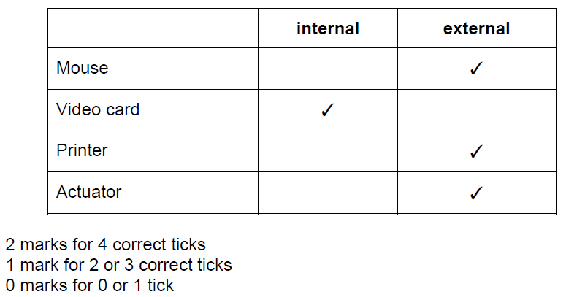 | 2
3 | 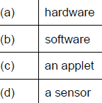 | 1  1  1  1
4 | Three from:  Ergonomic keyboard  Ergonomic mouse  Microphone  Wrist rest | 3
5 | Two from:  Does not need access to the internet  Fewer issues storing the data as the connection could drop during storage if the cloud is used  More control over the stored data | 2
6 | 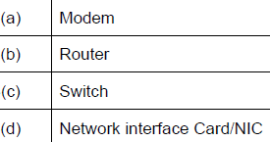 | 1  1  1  1
7 | They tend to have a more limited number of read and writes  More expensive per Gb than HDD | 2
8 | Two from:  Spam is junk mail  Sent in large numbers to inboxes  Unwanted/unsolicited emails  Fills the inbox  Used for advertising  Used for phishing/spreading malware | 2
9 | Two from:  Easier to hack as data is always available  Lose control of your data  More than one copy available to access therefore security is reduced  More difficult to delete all copies of the data | 2

SECTION B
10 c (i)  (ii) | Four from:  The laws within a country//In some countries emails are monitored and people are punished for what they write  Using emails for marketing purposes//Laws differ in different countries  Netiquette  Local guidelines set by an employer  The need for security//Some countries monitor keywords in emails  Password protection does not allow people to see the contents  Cultural offences  Two from for example:  Include a clear, direct subject line  Use a professional email address  Use professional salutations  Use exclamation points sparingly  Be cautious with humour/sarcasm/slang  Proofread the message before you click send  Do not use capital letters as it implies shouting  Do not use swear/offensive words  Do not use defamatory comments  Protect others privacy | 4  2
11 | 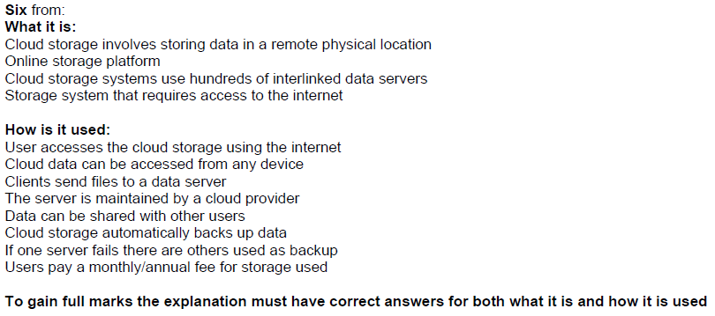 | 6
12 a  12b | Two from:  Internet etiquette  Set of social conventions  They show common courtesy when communicating online  Four from:  Do not use capital letters as it relates to shouting  Do not use abusive/vulgar language/threatening behaviour  Be clear in the text sent  Always check spelling and grammar  Remember that sarcasm does not communicate well  Respect other’s privacy  Respect other people’s views  Do not use too many emoticons  Do not use text language/slang  Do not spam  Do not send inappropriate links | 2  4
13 | 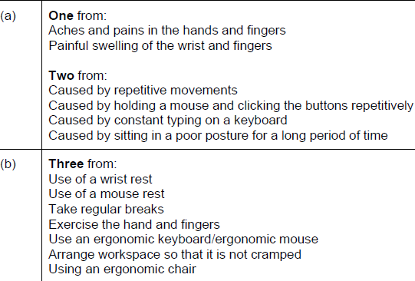 | 3  3
14 | Four from:  Copyright is the legal and exclusive right to copy, or permit to be copied, some specific work  If you own the copyright on the content of a web page someone else cannot make a copy of it without your permission  Copyright usually originates with the creator of a work, but can be sold, traded, or inherited by others  If you blog, take photographs, publish music, or otherwise produce copyrightable content, you legally own that content  Whether you want to let other people use it or not is your decision  If you want to use other people’s content, you have to understand permissions and licensing, what is legal and what  isn’t//Read Terms and Conditions  Supports the original producers of the software/content | 4
15 | 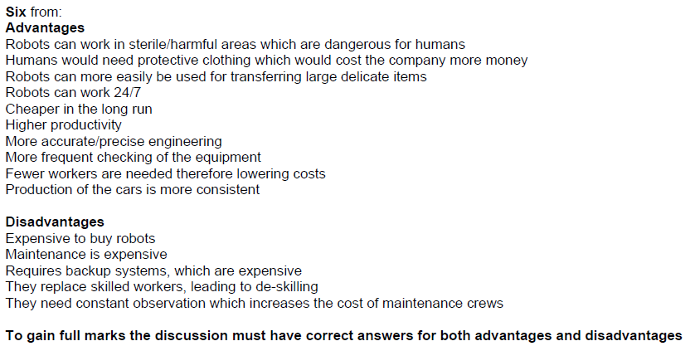 | 6
16 | Max four from:  Multiple spelling/grammatical errors  Asked to carry out tasks immediately  Asking to click on a link  Does not ask for you by name  Stored in a SPAM folder  Email asks for personal information  Large amount of repeated emails from same user  Lots of other similar email addresses in the send to box  Max four from:  Use a spam filter  Not filling your details on online form  Not replying to spam emails  Not having an auto reply set  Not consenting to marketing when providing details to a company  Do not give email address | 6

SECTION C
17 a  b | Three from:  Oxygen  Light  pH  Turbidity  Six from:  Advantages  More accurate results produced  Computer does not forget to take a reading  Results are processed automatically  Readings can be taken at more points as many humans are needed  Readings can be taken that would be impossible for humans  Data can be analysed continuously  Readings can be taken more frequently  Safer than using humans  Better response time  Can work 24/7  Can be placed in remote areas where humans could not work  Fewer humans required therefore reducing the cost  Disadvantages  Computer responds less to unusual circumstances  Computer equipment can be more susceptible to atmospheric conditions  Computer equipment is more likely to be damaged or stolen by vandals  To gain full marks the discussion must have correct answers for both advantages and disadvantages | 3  6
18 a  b | Four from:  Is debit card number valid/exists  Does name entered match that on system  Is expiry/start date valid/matches date stored on system  Does security code/CVV entered match that stored on system  Is there available credit/funds in the bank account  Checks for unusual spending patterns  Is card blocked/reported stolen/lost  Four from  Computer looks up the date of performance/performance reference number  Matching record is retrieved  Checks/Searches if the seats are available  Flags the seats to stop double booking as temporary hold  Reduced number of available seats by the number booked//seats flagged as fully booked  Calculate cost of seats  Prints ticket/generates e-ticket  E-ticket/ticket sent to customer  Receipt is printed/Verification email sent  Data is checked for accuracy  If booking not completed, then temporarily hold flag is removed from the seat  Reduce number of seats available once the booking is complete | 4  4

