1. Create a program for driving a car. The car has to move 5 steps right. [15]

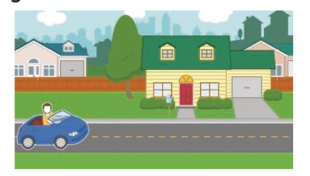

1. Open ScratchJr. /1
2. Find a Background with a road. /1
3. Select a Driver character. /1
4. Add this code to the Driver character. /3



1. Run the program. /1
2. Does the car move to the right?________ /2
3. Did you notice the error?________ /2
4. Find the error and correct it. /2
5. Run your program with the correct code. /2

|  |  |  |  |
| --- | --- | --- | --- |
| **Rubric for Creating Program** | | | |
|  | 1 | 2 | 3 |
| Create Project |  |  |  |
| Add Sprites |  |  |  |
| Set Backdrops |  |  |  |
| Make codes for Sprites. |  |  |  |
| Find the error |  |  |  |
| Run the program |  |  |  |
| **Key**:   1. Needs more opportunities to develop this skill. 2. Beginning to demonstrate this skill. 3. Has achieved this skill. | | | |