**I) Fill in the blanks. [4]**

Works Hop Correctly Fixing

a) To make your character jump, you should use the ___________ block.

b) Testing is when you run your program to see if it _____________.

c) Debugging means finding and ___________ mistakes in your program.

d) It’s important to test your program frequently to ensure it works __________.

**II) Write the steps in the right order to finish drawing a square. [4]**

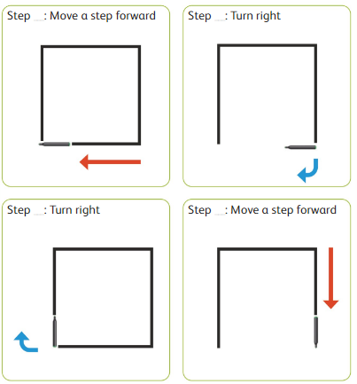

**III. Match the following. [5]**

|  |
| --- |
|  |
|  |
|  |
|  |
|  |

|  |
| --- |
| 1. Move forward 1 step |
| 1. Turn right |
| 1. Turn left |
| 1. Move backward 1 step |
| 1. Stop program |

**IV. Write the missing letter. [2]**

1. D__b__g
2. T__ s__