***Edward Lear***

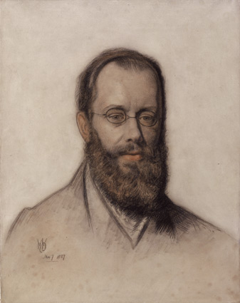

***Edward Lear lived from 1812 to 1888, in the Victorian period. He was good at all sorts of things. He illustrated books about birds and animals with beautiful drawings, and painted colourful pictures of all the places he travelled to in the world. He played the guitar and the flute and wrote lots of songs. He was also a well-known writer of stories and poems. He is most famous nowadays for writing ‘nonsense verse’ – quirky poems full of funny ideas and words that have a strong rhythm and lots of rhyming. Lear also liked writing a special kind of funny poem called a ‘limerick’.***

Unit 1 Day 1

***The Owl and the Cat***

Unit 1 Days 1&2

The Owl and the Cat went to sea

In a beautiful pea-green boat,

They took some honey and plenty of money,

Wrapped up in a five-pound note.

The Owl looked up to the stars above,

And sang to a small guitar,

“O lovely Cat, O Cat my friend,

What a beautiful Cat you are,

You are,

You are!

What a beautiful Cat you are!”

Cat said to the Owl, “You elegant fowl!

How charmingly sweet you sing!

O let us be friends! Too long we have tarried:

But what shall we do for a ring?”

They sailed away, for a year and a day,

To the land where the Bong-Tree grows

And there in a wood a doggy-wig stood

With a ring at the end of his nose,

His nose,

His nose,

With a ring at the end of his nose.

“Dear dog, are you willing to sell for one shilling

Your ring?” Said the doggy, “I will.”

So they took it away, and were made friends next day

By the Turkey who lives on the hill.

They dined on mince, and slices of quince,

Which they ate with a runcible spoon;

And hand in hand, on the edge of the sand,

They danced by the light of the moon,

The moon,

The moon,

They danced by the light of the moon.

*Edward Lear*