**Sentence starter**

*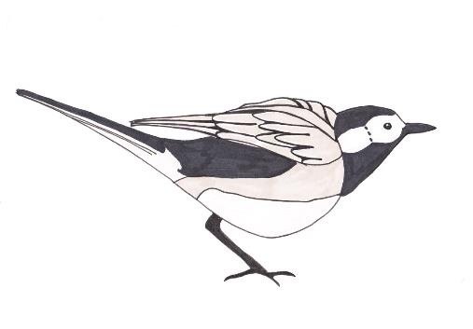If I were a bird I would.* *..*

Unit 1 Day 1

**How and where would you go?**

If I were a bird I would __________________________________________________________

If I were a bird I would __________________________________________________________

If I were a bird I would __________________________________________________________

Try using a different synonym for *fly* in each of your sentences (e.g. *hover, glide, soar, swoop, flap or* *flutter)*

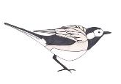

Unit 1 Day 1