**COMPARISON OPERATOS AND CONDITIONAL STATEMENTS**

1. Open MakeCode using Google and click on new project
2. Create a rock, paper scissors game using following instructions:
3. Start program when micro:bit is shaken
4. Create a variable called **Hand**
5. Choose a random number from 1 to 3.
6. Set variable hand to value in Step 3.
7. If variable Hand = 1, then
8. Show LEDs of rock icon

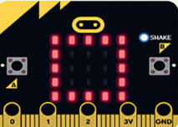

1. If variable Hand = 2 , then
2. Show LEDs of paper icon

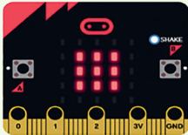

1. If variable Hand = 3 , then

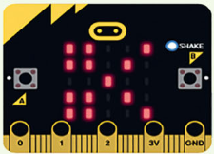

1. Show LEDs of scissors icon
2. Click on the play button to test your code.