**I. Choose the right answer.**

|  |  |  |  |  |
| --- | --- | --- | --- | --- |
| **Search** | **Field** | **Data table** | **Forever or Repeat** | **Condition-Controlled** |

1. Ameera is a game programmer she needs to repeat some tasks repeatedly and over and over again. Repetition in Scratch 3 uses either ___________ or _________ loops.
2. School have stored details of the students. __________ is a collection of data about student.
3. _____________________ block is repeated until a condition is met.
4. Each column in a data table represents a unique ___________.
5. To answer some questions a ___________ must be performed in any database.

**II. State whether the statements are true or false.**

6. Each column in a data table represents a unique field.

7. Calculations cannot be performed on data that is of type Text.

8. Some fields can hold data in different formats.

9. A field with data type Text can only store letters.

10. A field with a data type of Yes/No can store data with many

possible values.

**III. Match the following.**

|  |  |
| --- | --- |
| 11. Touch logo | b. To display letters, numbers,images and patterns. |
| 12. Show happy icon | c. Music block-To play the sound |
| 13. Play sound hello | d. Programmed to start the events when it is touched. |
| 14.LED Displays | e. Input block- To start the |
| 15. On button A+B | f. Basic block- Displays the happy face |

|  |  |  |  |  |
| --- | --- | --- | --- | --- |
| 11. | 12. | 13. | 14. | 15. |
|  |  |  |  |  |

**IV. Answer the following**

**16. Observe the data table and answer the questions.**

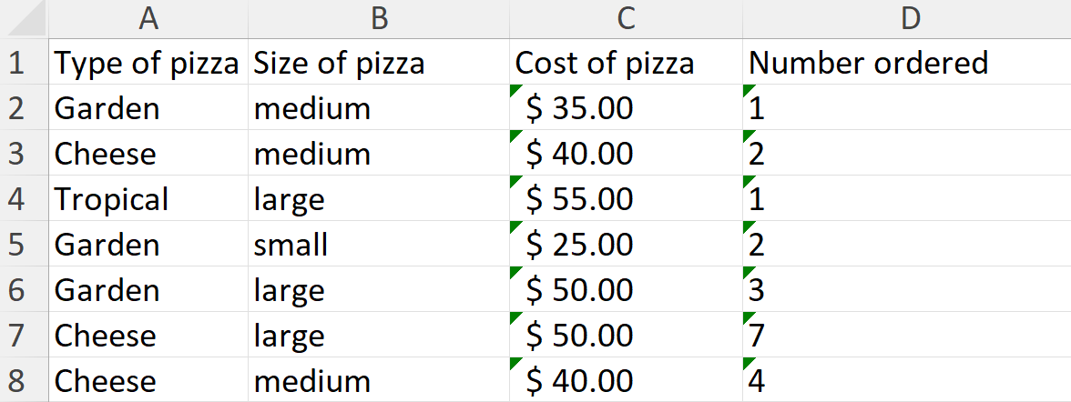

a. How many large pizzas are there?

i. One

ii. Three

iii. Four

b. Which types of pizza is having highest number of orders?

i. Garden

ii. Cheese

c. What is the data type of field “Cost of pizza”?

______________________________________________________________

d. How many records and fields are there in the given table?

_______________________________________________________________

_______________________________________________________________

e. Identify and encircle the field names in the table.

17. Ibrahim is a document controller who designs and maintain MS Word in an IT company. He shared his document online to his manager, then he made a corrections and changes to his document.

Guide Ibrahim to understand what is track change feature?

_____________________________________________________________________

_____________________________________________________________________

_____________________________________________________________________

_____________________________________________________________________

_____________________________________________________________________

18. Read and complete the algorithm in the given table.

**The sound should repeat in 2 seconds intervals when Green flag is clicked.The sound should stop when the up-arrow key is pressed.**

|  |  |
| --- | --- |
| **Steps** | **Instructions** |
| 1. | Start program when _________________ |
| 2. | Start sound _____________ |
| 3. | Wait _________ seconds |
| 4. | Repeat steps __________ and __________ until the ________-key is pressed |
| 5. | Stop program |

19 i. List the different health risk factors due to the over use of computer devices.

______________________________________________________________________

______________________________________________________________________

______________________________________________________________________

______________________________________________________________________

______________________________________________________________________

______________________________________________________________________

ii. Explain how to protect your health from the potential risks of excessive electronic device use?

_____________________________________________________________________

______________________________________________________________________

______________________________________________________________________

_____________________________________________________________________

______________________________________________________________________

______________________________________________________________________

_____________________________________________________________________

______________________________________________________________________

______________________________________________________________________

_____________________________________________________________________

______________________________________________________________________

______________________________________________________________________