Card1

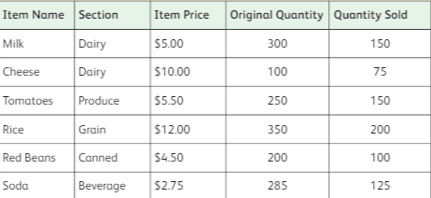

Find the following;

* Number of fields _______________
* Number of records _____________
* Data types of each fields _______________

Explain about the data table from the above the image.(Speak)

Card2

Label the following in the given image of microbit.

* 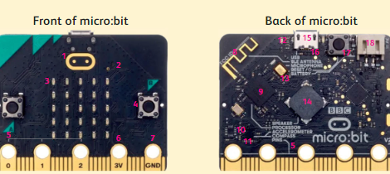Touch logo
* Button A
* Button B
* LED Display
* 3V pin

Card 3

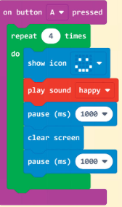

Identify the block names which they belong to.

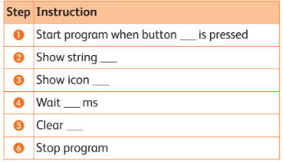Card 4

Read the below algorithm and fill it.

When button A is pressed, a name scrolls across the display followed by a pitchfork icon. After 500 ms, the screen clears.

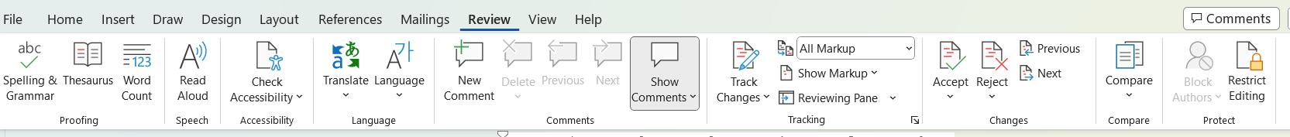Card 5

Write the steps to apply the track changes.