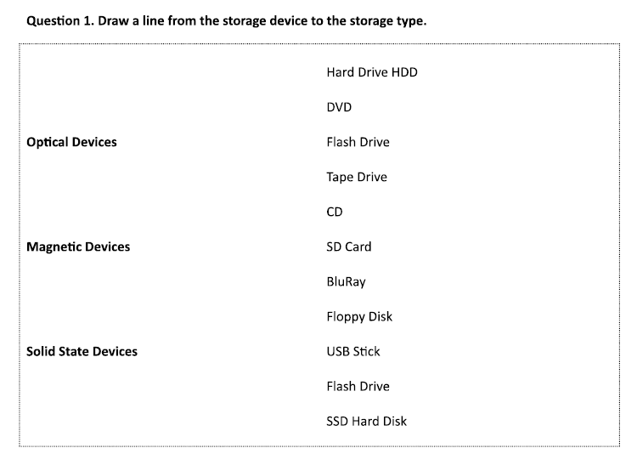

**Question 2:**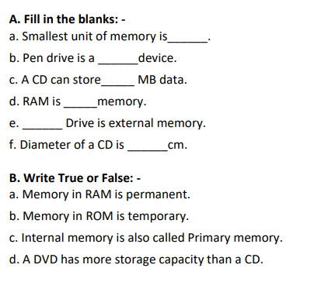

Bit

Solid State Storage

650

Volatile

Flash

12

False

False

False

True